**PROJECT SUMMARY**

* Chit Software is a specialized application designed to manage and automate the operations of chit fund organizations. Chit funds are a popular savings and credit scheme in many countries, where a group of people contribute a fixed amount periodically and one member gets the entire sum as a lump sum in a scheduled draw or auction.
* Chit Software simplifies and enhances the management of these funds by providing a comprehensive suite of features for administrators and users. Leveraging the power of JavaScript and PHP, this software facilitates efficient management of chit-related operations, including Customer Creation, Group Creation, auctions, settlements, collections, and more.
* It offers a user-friendly interface that integrates seamlessly with various backend systems to provide a robust solution for managing chit funds and Offers a centralized platform to manage all aspects of chit fund operations, from group creation to auction management and financial tracking.

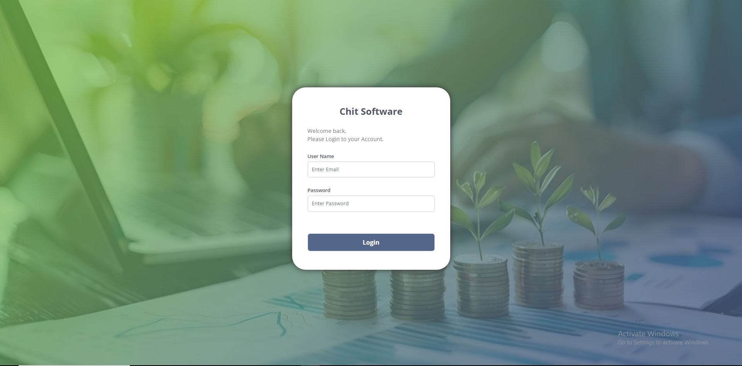

**TECHNICAL SPECIFICATION**

* CORE PHP
* HTML, CSS, BOOTSTRAP
* JAVASCRIPT, JQUERY
* MYSQL

**SOFTWARE REQUIREMENTS**

* XAMPP VERSION - 7.4
* PHP VERSION – 8.2
* BOOTSTRAP VERSION - 4

**SYSTEM REQUIREMENTS**

* OS – Windows 10 - 64 bit
* Processor Intel i5
* Ram 8GB
* Microsoft .Net Framework 4.5.2 or above

**MODULES**

* DASHBOARD
* MASTER
* ADMINISTRATION
* AUCTION
* SETTLEMENT
* COLLECTION
* ACCOUNTS
* CUSTOMER DATA
* GROUP SUMMARY
* ENQUIRY
* REPORTS
* BULK UPLOAD

**1. DASHBOARD**

* In the Chit Software Dashboard, users can monitor key financial activities such as group creation, auction management, collection tracking, and settlement processes.
* A dropdown menu labeled "**Select Branch**" allows users to filter or select specific branches of the financial institution.
* It allows the user to select a specific branch. This selection will filter data and reports related to that branch, ensuring the user sees only relevant information for the chosen branch.
* **Group List**
* It displays the list of chit fund groups created in the selected branch. It helps the user to monitor group information such as chit value, total months, date of formation, and commission percentage.
* **Auction List**
* It displays the list of auctions that are scheduled to take place today or in the near future. It helps users track and manage upcoming auctions, ensuring they stay informed about the most recent and imminent events.
* **Collection**
* It displays the total amount collected from all chit groups and the specific amount collected today. It gives users an overview of financial inflows from member contributions.
* **Settlement**
* It shows the settlement details for the chit groups, including both total settlements and today's settlement. Settlements represent payouts to members who have won the auctions.
* **Collection Summary**
* It displays the total amount collected from all chit groups for the current month. It shows the amount still pending from members for the current month. This helps track overdue payments and plan collection efforts.
* It shows the unpaid dues carried forward from previous months. It aids in understanding long-term pending collections. Represents the total amount pending collection, including both current and previous dues.

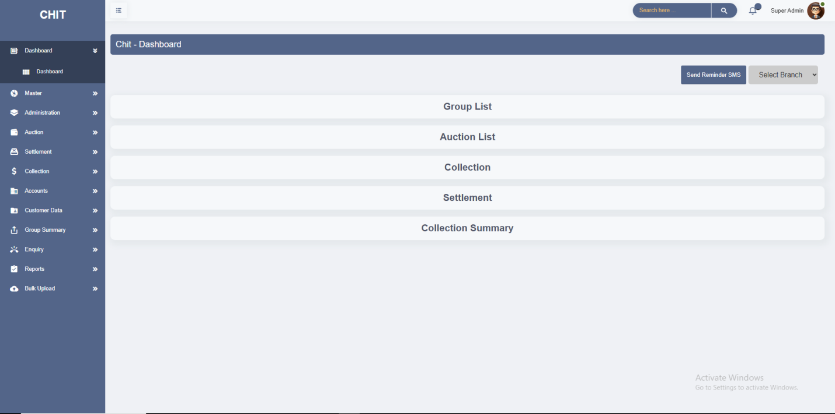

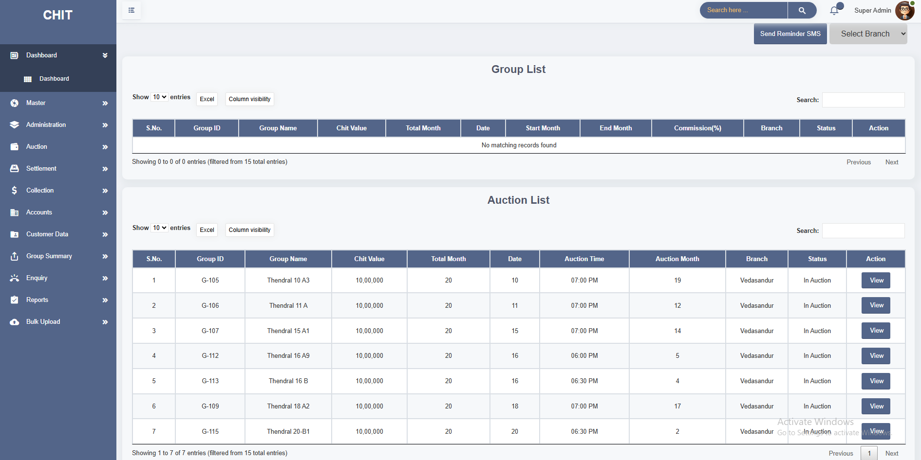

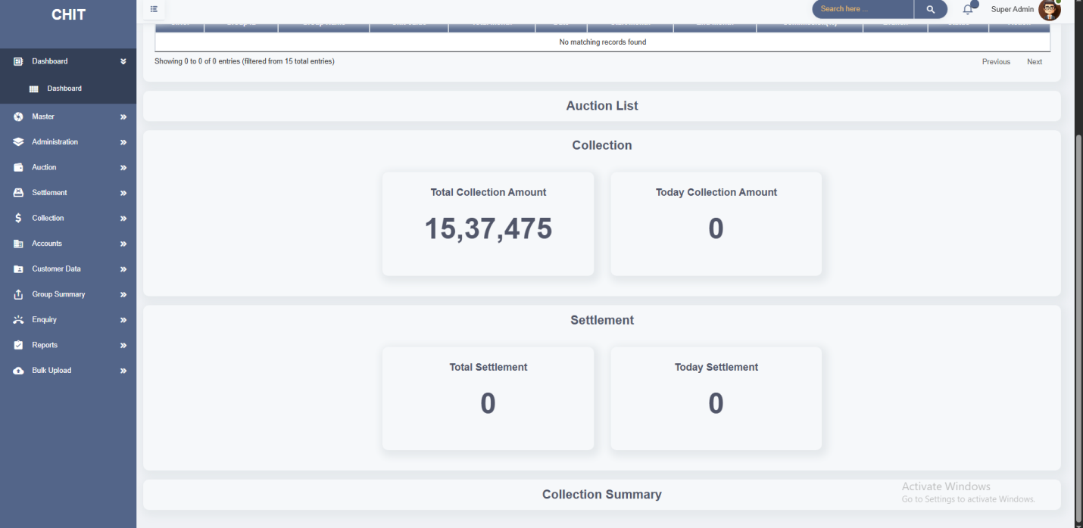

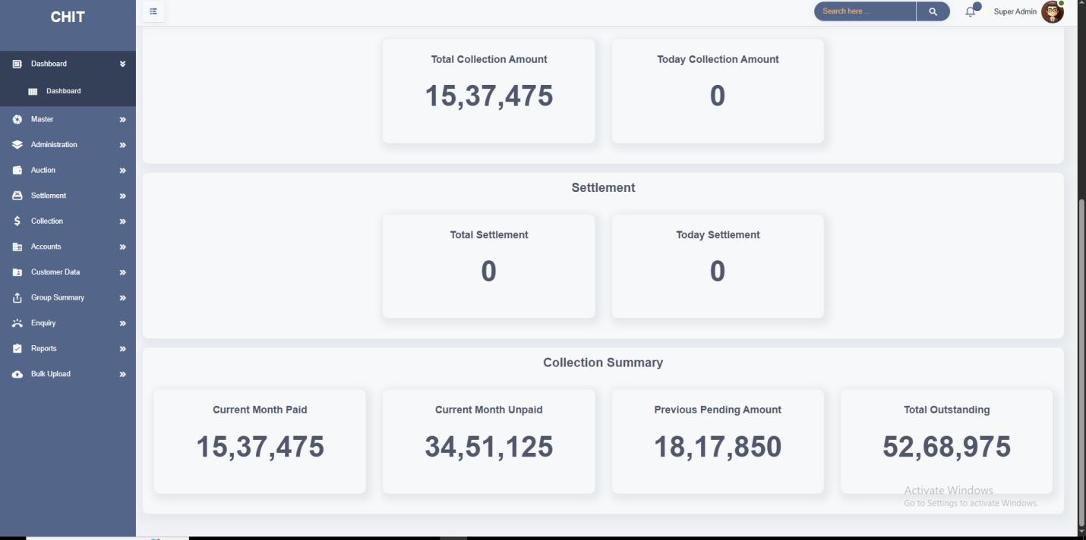

**2. MASTER**

* This module has 4 Screens. **1.Company Creation, 2.Branch Creation, 3.Customer Creation, 4.Group Creation.**
* **Company Creation:**
* The **Company Creation** screen in Chit Software is a crucial feature designed to allow administrators to create and manage company profiles within the system. This screen ensures that all necessary details are accurately captured to establish a company's identity within the system. It allows for the entry of comprehensive information, both general and communicative, about the company.
* The Company Creation screen is designed for single-company entry, ensuring that only one company profile can be created and managed through this interface. This limitation is intentional to maintain data integrity and prevent duplication within the system.

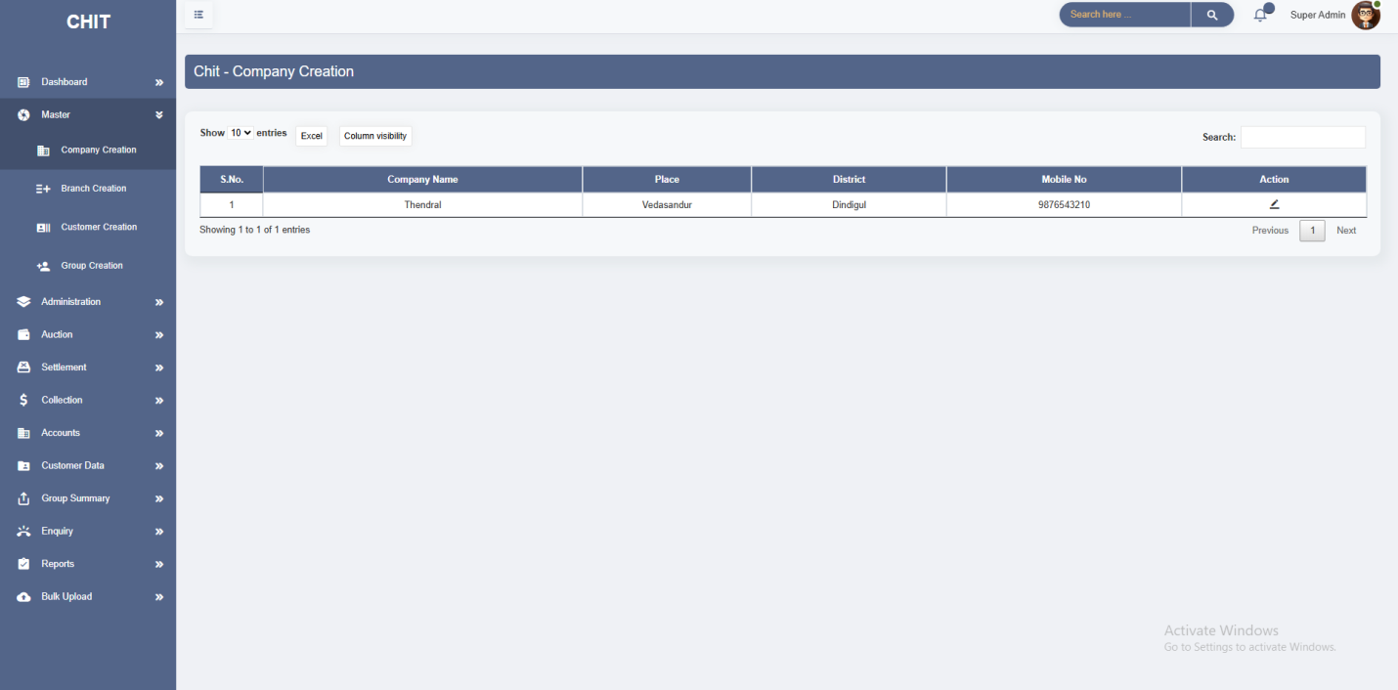

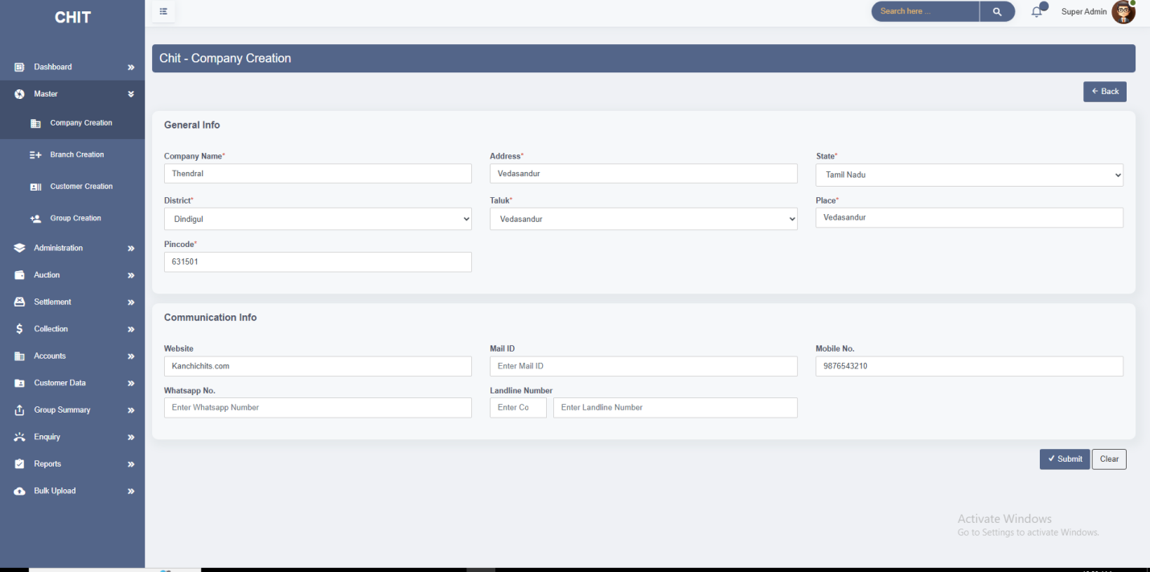

* **Branch Creation:**
* The **Branch Creation** screen in Chit Software is designed to enable administrators to add and manage branch details associated with a company. This screen allows users to input comprehensive information about each branch, ensuring that all branch-related data is accurately recorded and available for administrative and operational needs.
* It streamlines the process of adding and managing branches, making it easier to keep track of multiple branch locations and details.
* Since only a single company can be created in the system, this screen allows for the establishment of multiple branches under that company.

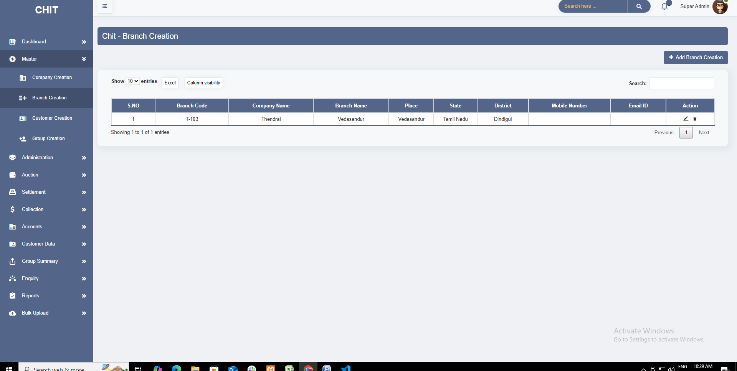

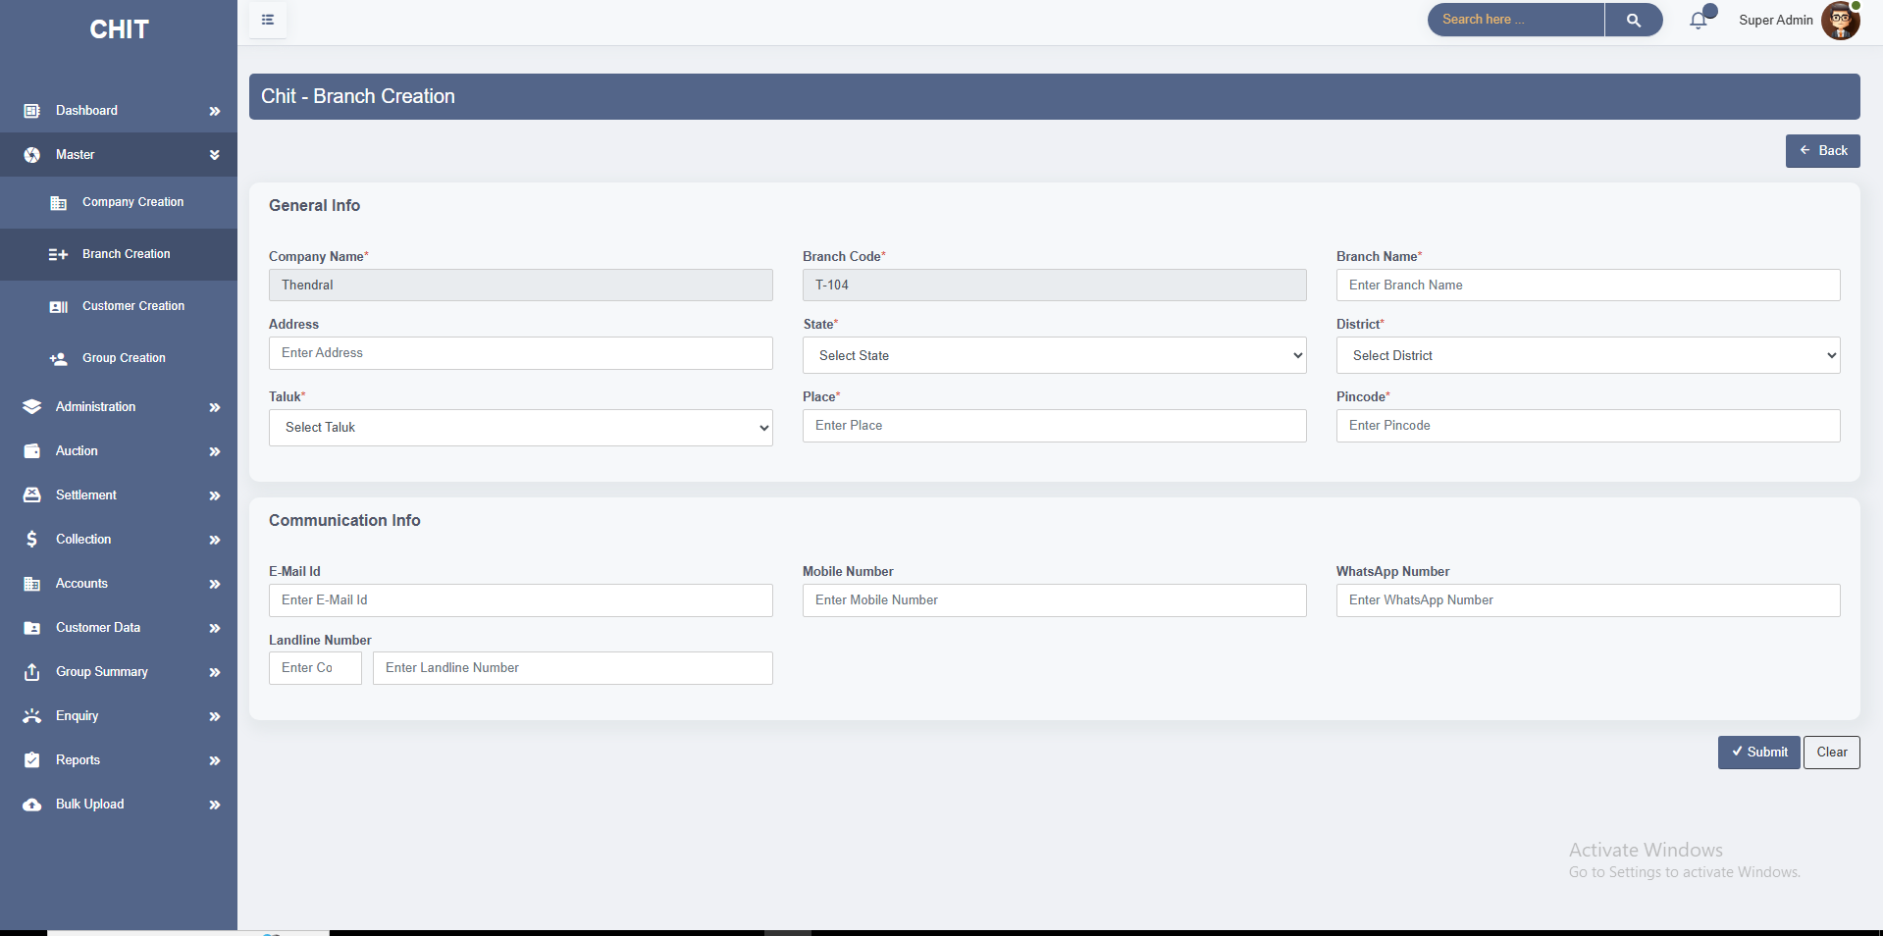

* **Customer Creation:**
* The **Customer Creation** screen in Chit Software is designed to facilitate the addition and management of new customer records. This screen captures essential details about customers, including personal information, contact details, financial information, and references, ensuring a comprehensive record is maintained for each customer.
* It provides information on how customers came to know about the chit scheme, which helps in understanding the effectiveness of various promotional channels.
* It streamlines the process of customer registration, reducing manual data entry and potential errors.

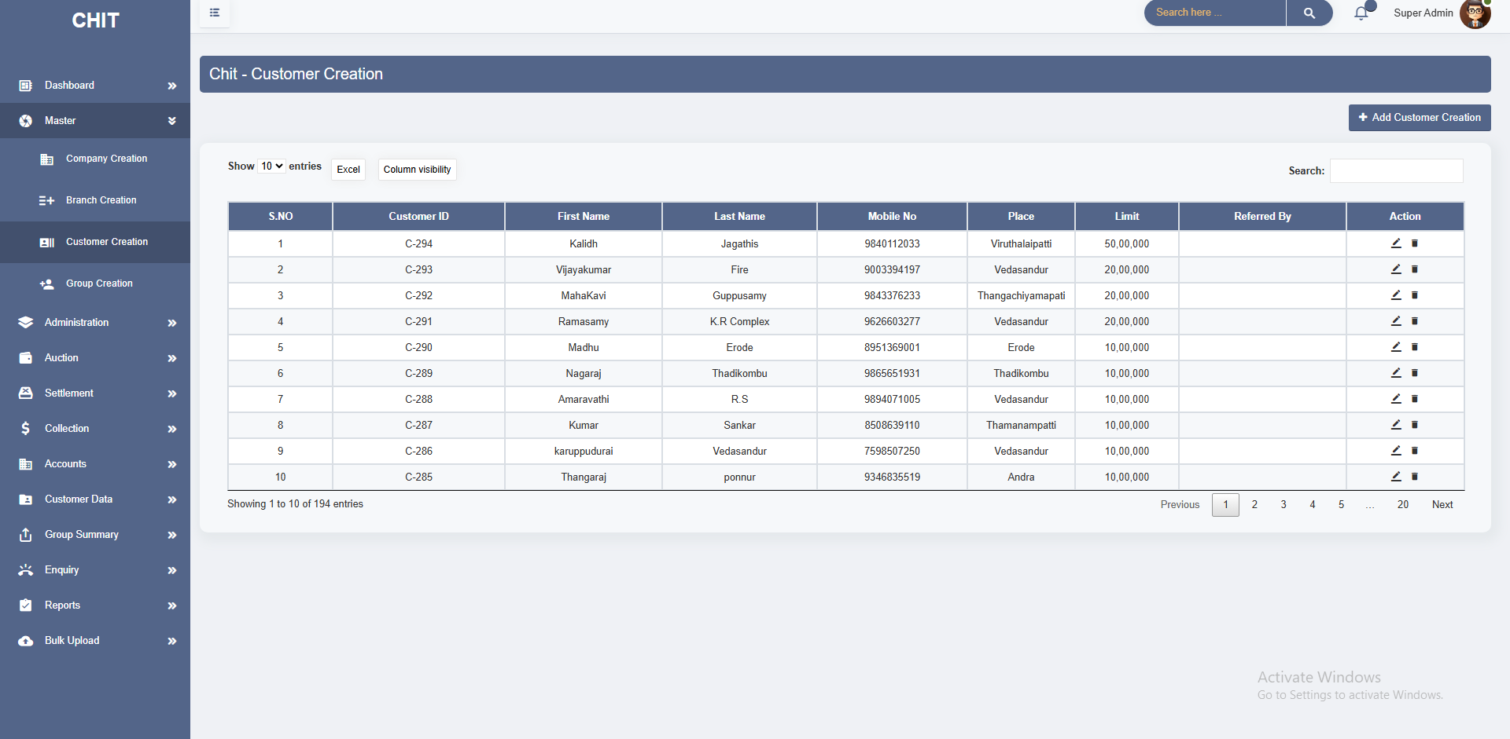

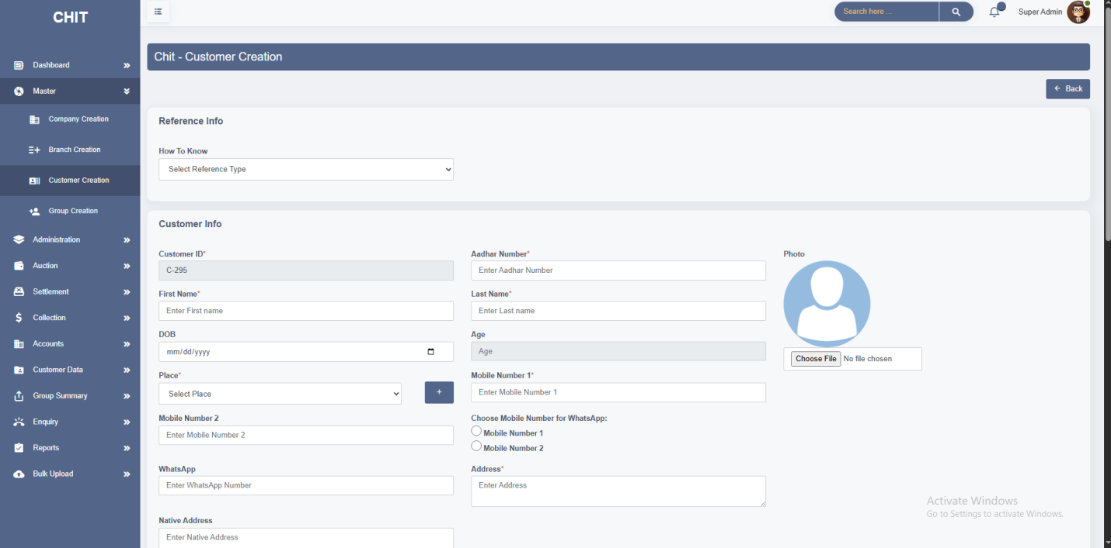

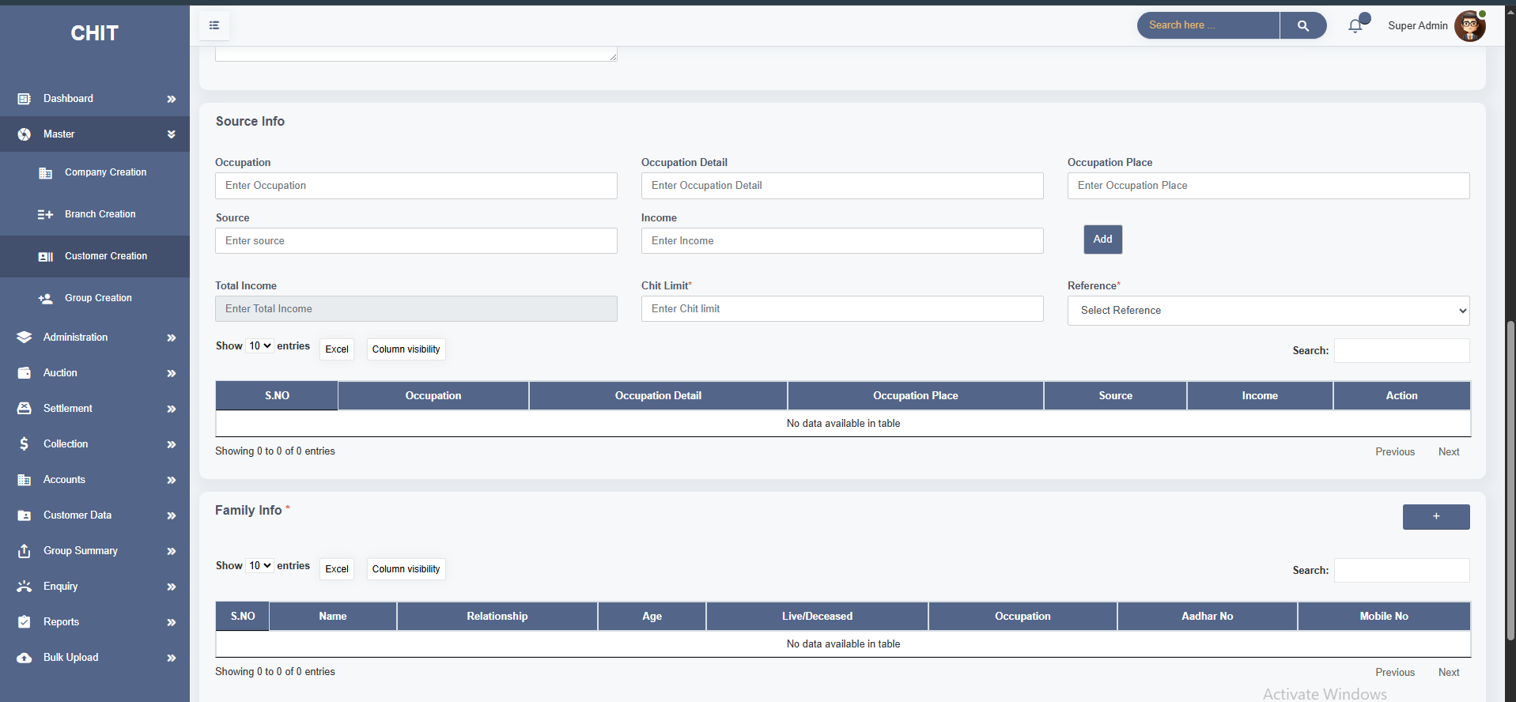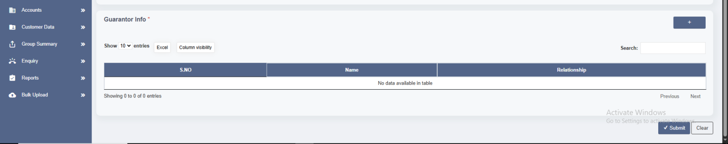

* The **Add Place** modal is a feature in the customer creation screen of Chit Software that allows administrators to define and manage places or locations associated with

Customer records. This functionality is essential for ensuring that place-related information is accurate and up-to-date, facilitating effective customer management and documentation.

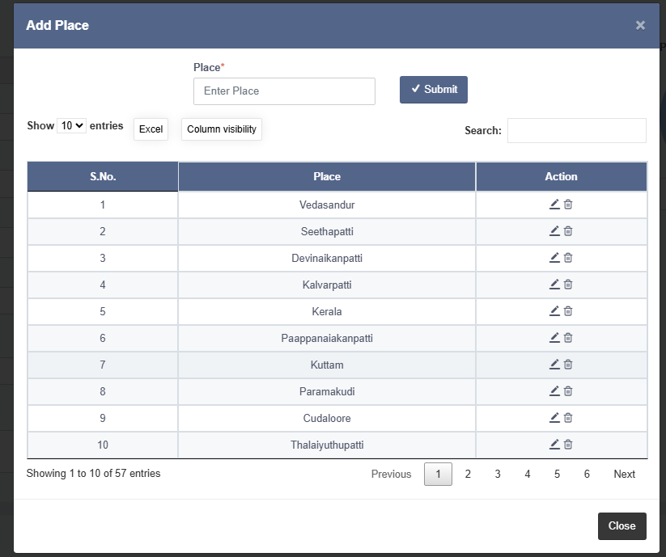

* The **Family Info** modal in the Customer Creation screen of Chit Software is an essential feature that allows users to capture and manage detailed information about a customer's family members. This modal is used to collect and store family-related details that may be relevant for customer assessments, eligibility checks, and maintaining comprehensive records.

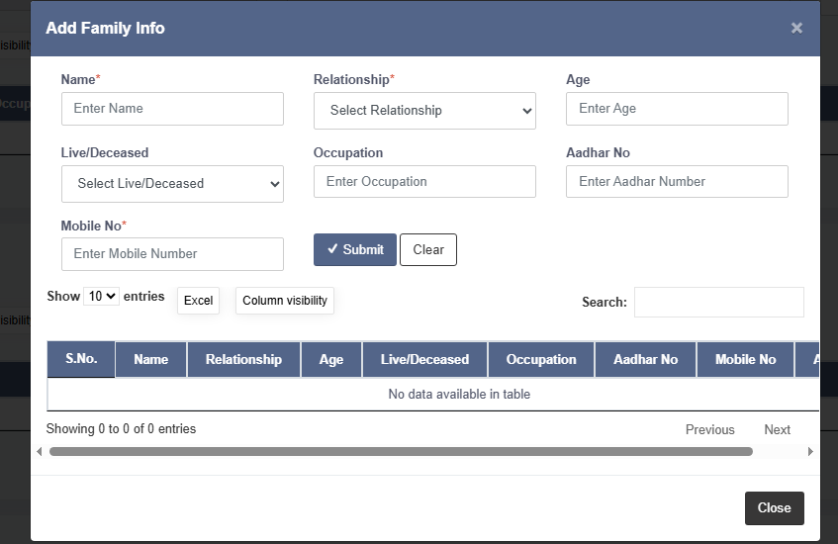

* The **Guarantor Info** modal within the Customer Creation screen of Chit Software is designed to capture and manage details about the customer's guarantor. This modal is crucial for collecting information related to individuals who will act as guarantors for the customer’s financial obligations or loans. The guarantor provides an additional layer of security and assurance for the financial institution.

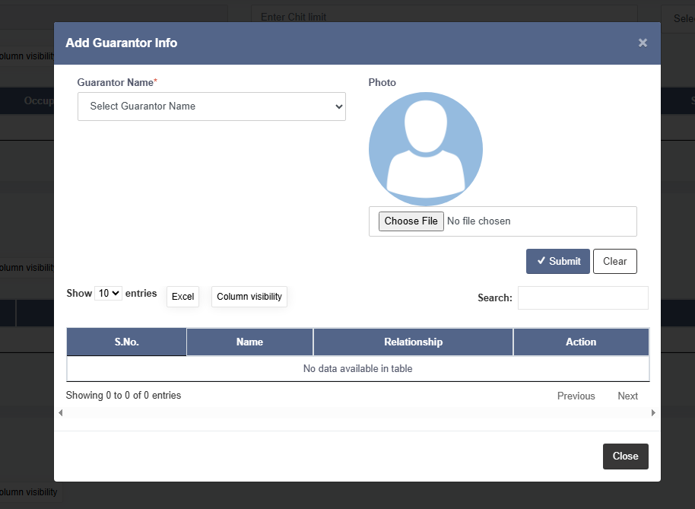

* **Group Creation:**
* The **Group Creation** screen in Chit Software is designed to facilitate the establishment and management of new chit groups. This screen allows administrators to input and configure details about each chit group, including financial specifics, timeframes, and associated branches. The creation of groups is central to the operation of chit funds, which are financial instruments used to pool and distribute funds among participants.
* The primary purpose of this screen is to set up new chit groups, each of which will operate according to the specified parameters. This includes member allocation, auction setup, scheduling, and branch mapping.
* If any of the following values change — **Date**, **Total Month**, or **Start Month** — the user must re-enter auction details to ensure consistency.

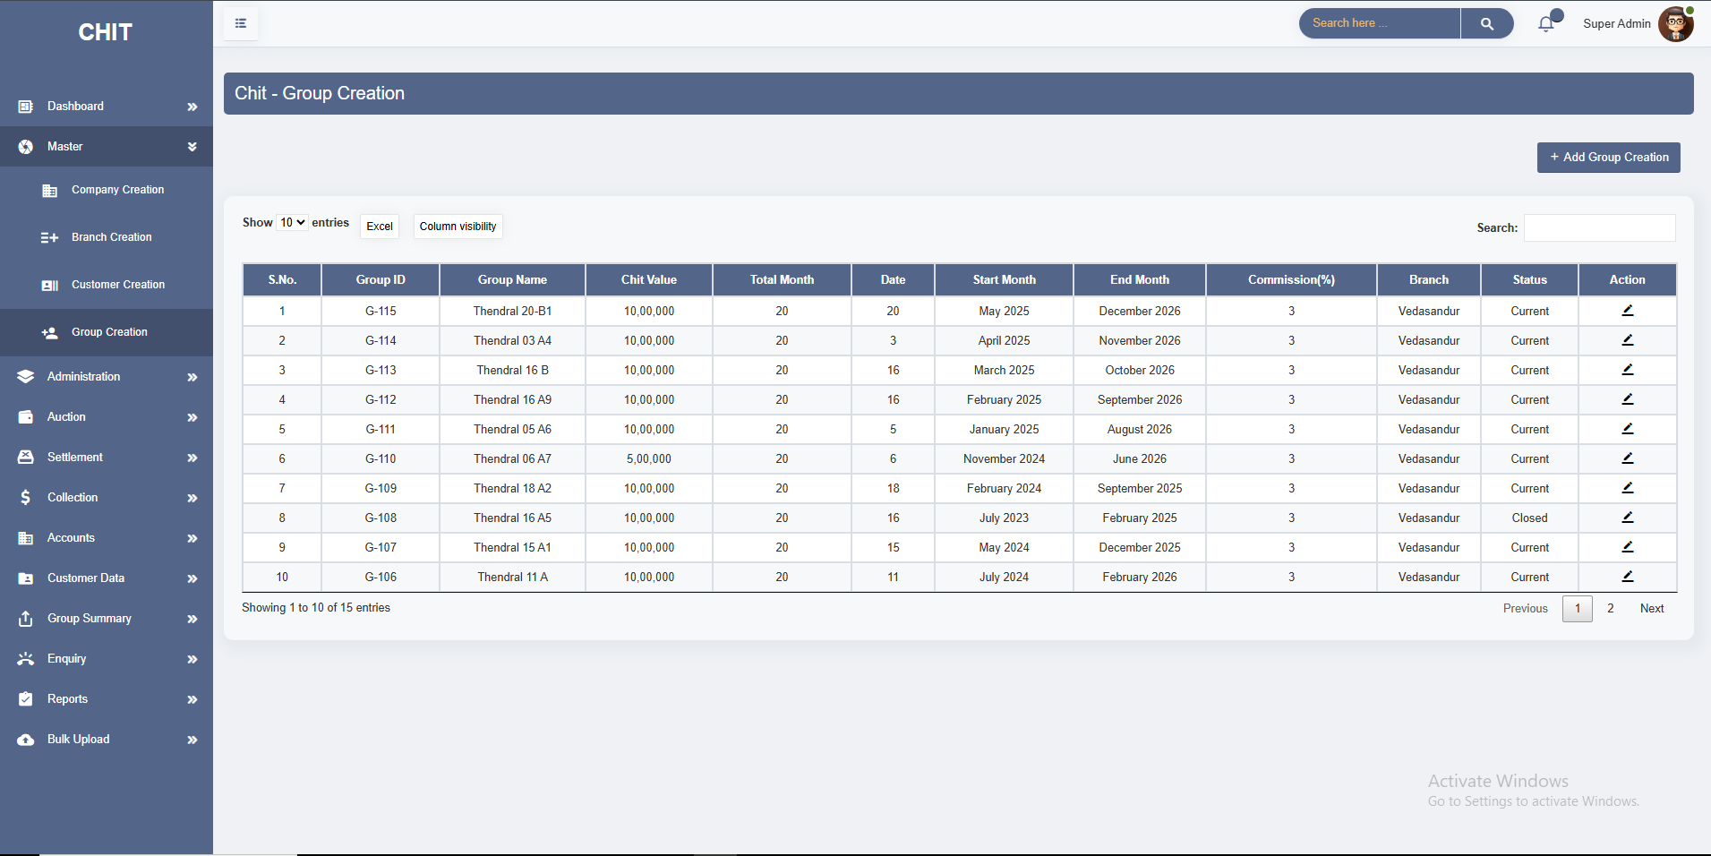

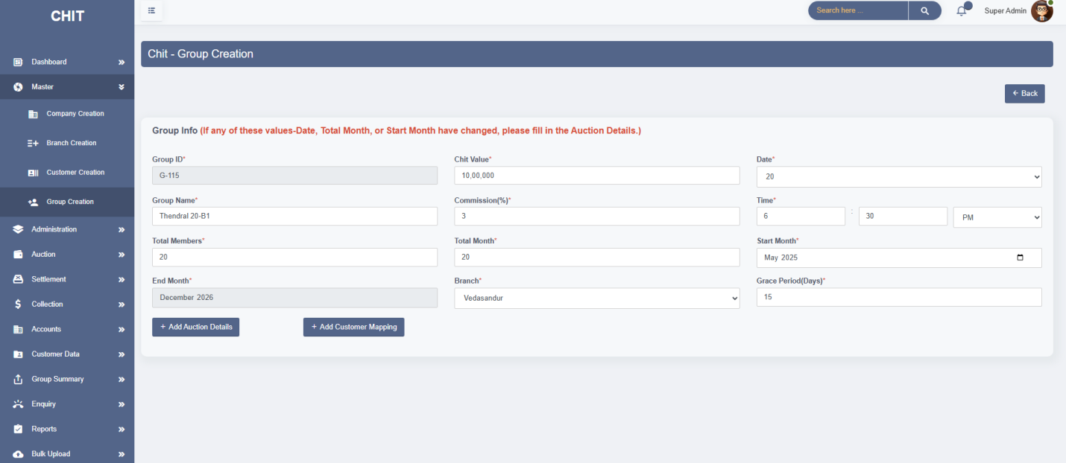

* The **Add Auction Details** modal is activated after entering the basic group details, specifically Date, Total Month, Start Month, and End Month. Once these values are inputted, the system provides a prompt to enter auction details. The modal auto-generates the list of months based on the Start Month and End Month values provided during group creation.
* This ensures that auction details are relevant to the specific period of the chit group. This modal ensures that all necessary information about high and low value for each month is captured accurately and linked to the respective chit group.

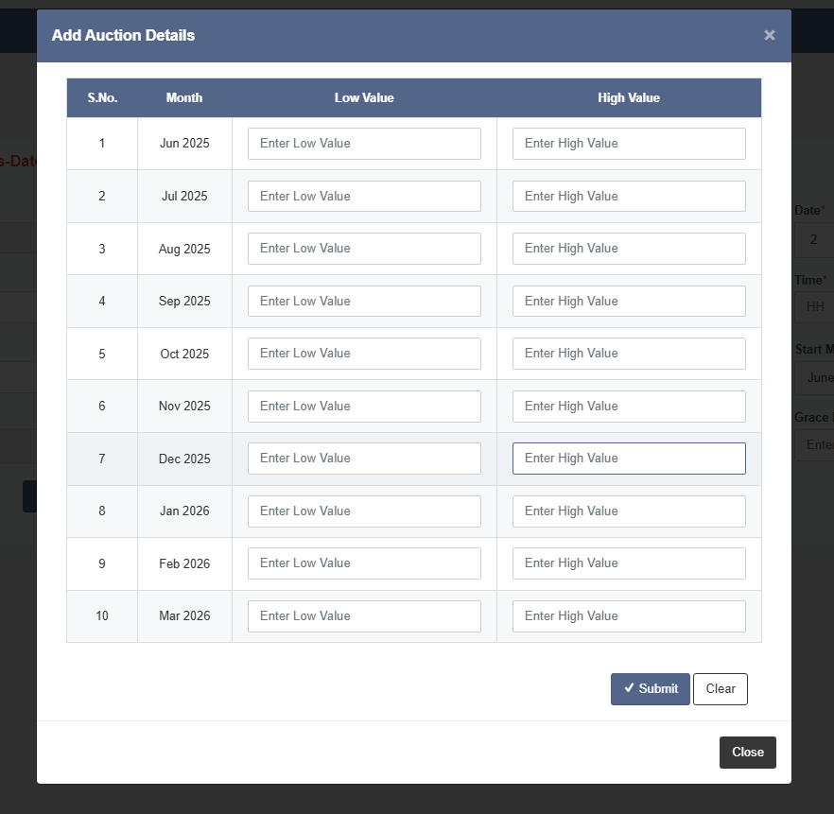

* The **Add Customer Mapping** modal in the Group Creation screen is designed to facilitate the assignment of customers to a particular chit group. This modal ensures that customers are mapped to a group based on the total members allowed in the group. It helps in managing and organizing customer data effectively, ensuring that the number of customers does not exceed the allowed limit for the group.
* User can select a customer, set their auction start month, and enter the share value. The system automatically calculates the share percentage for easy validation and Helps in organizing and distributing shares among multiple customers within a chit group.

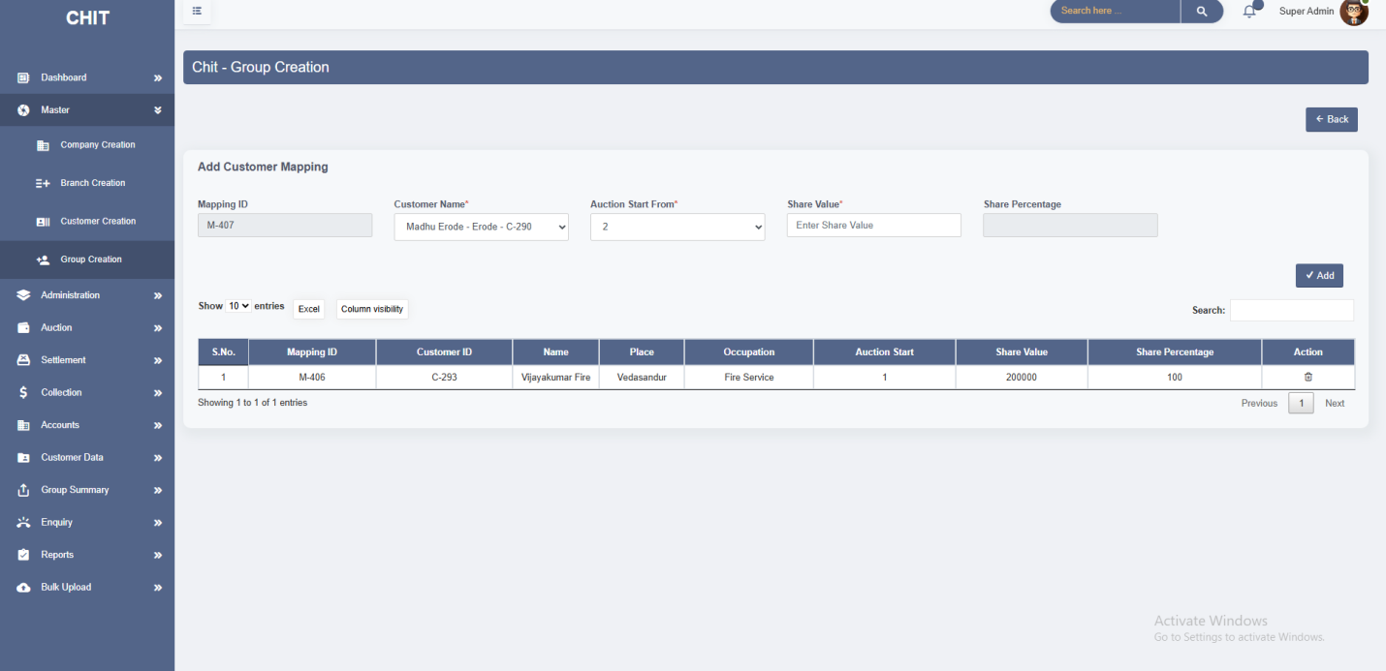

**3. ADMINISTRATION**

* This module has 2 Screens. **1. Bank Creation, 2.User Creation.**
* **Bank Creation:**
* The **Bank Creation** screen in Chit Software is designed to manage and record bank account details associated with the chit operations. This screen allows users to enter and store essential banking information, ensuring that all financial transactions related to the chit groups are accurately tracked and managed.
* It provides a centralized location for storing and managing bank details. This helps in organizing all banking information related to chit transactions in one place.

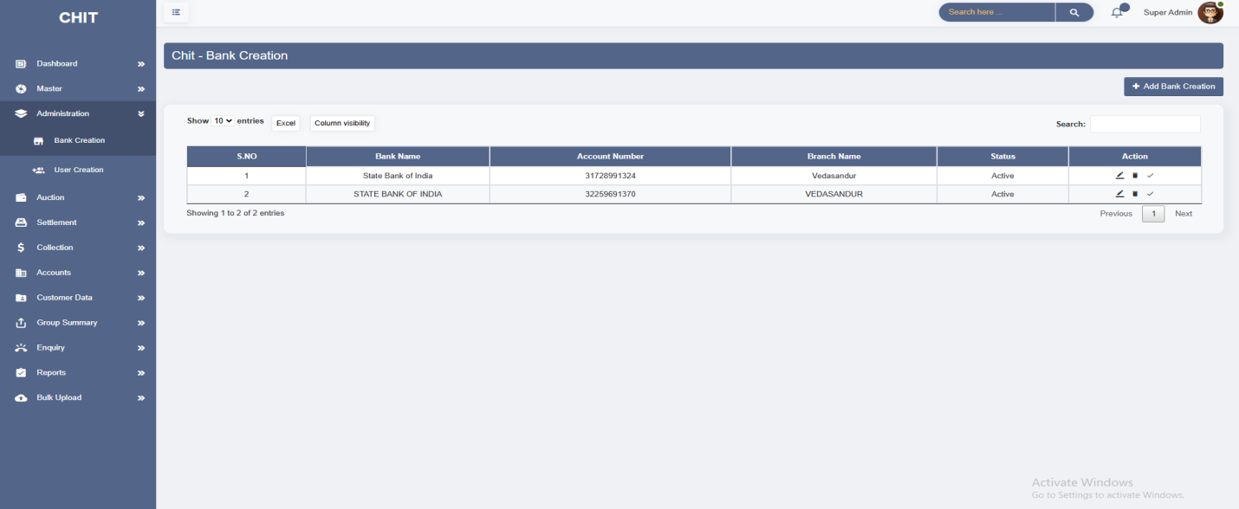

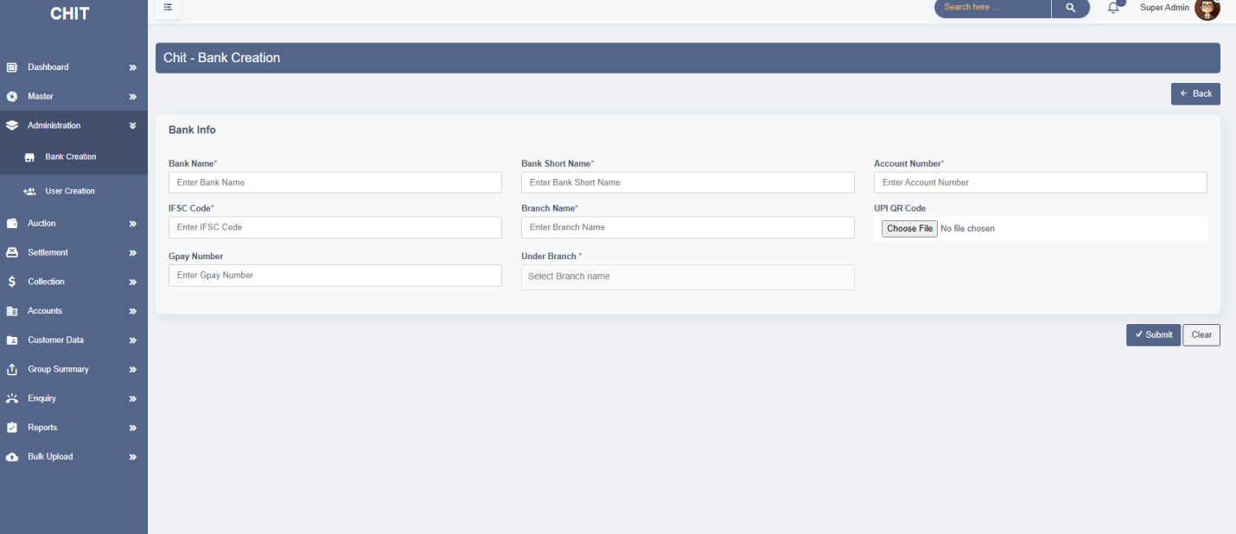

* **User Creation:**
* The **User Creation** screen in Chit Software is designed to manage and create user profiles for the system. This screen allows administrators to add new users, assign roles and permissions, and configure user-specific details essential for accessing and managing various functions within the software.
* It enables the customization of user profiles with specific details, including credentials and mapping info, ensuring that each user’s experience is tailored to their role and responsibilities.
* It provides users with checkbox options to grant access permissions to various modules and functionalities within the Chit software.

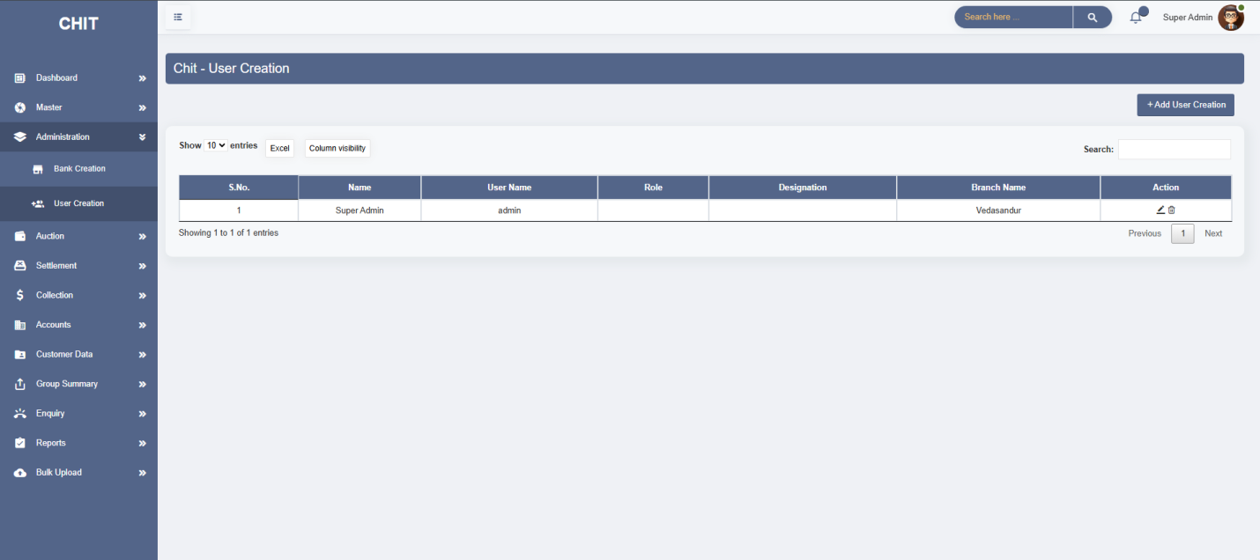

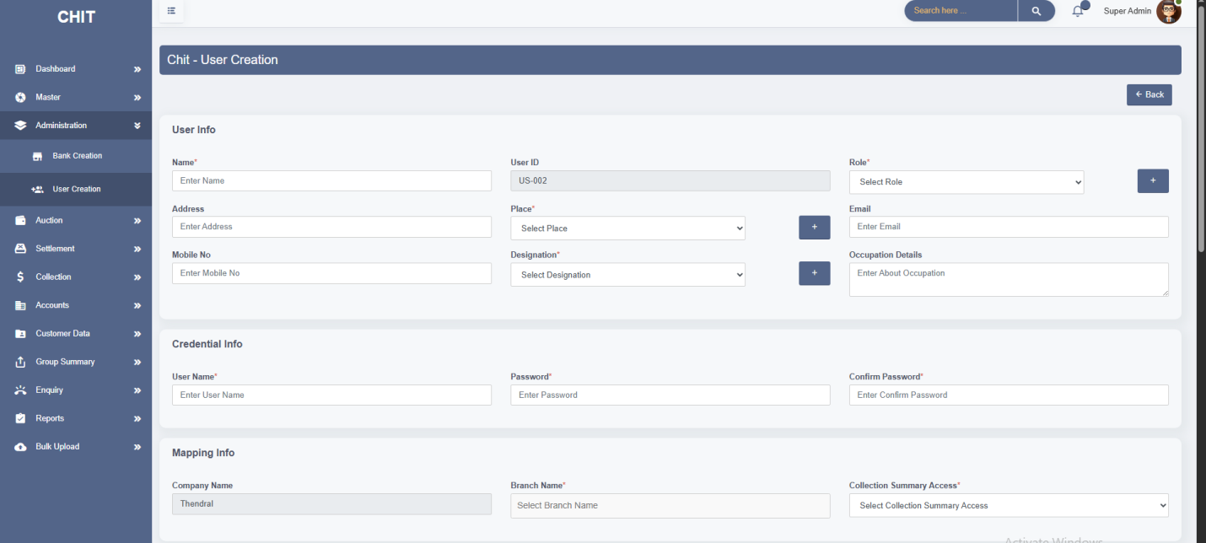

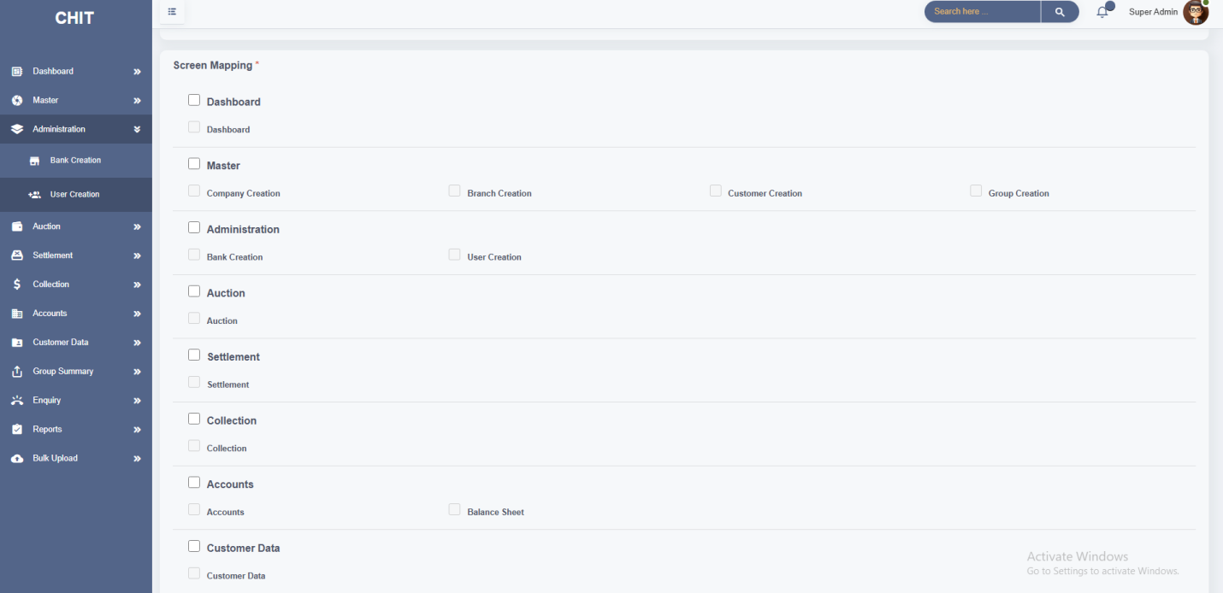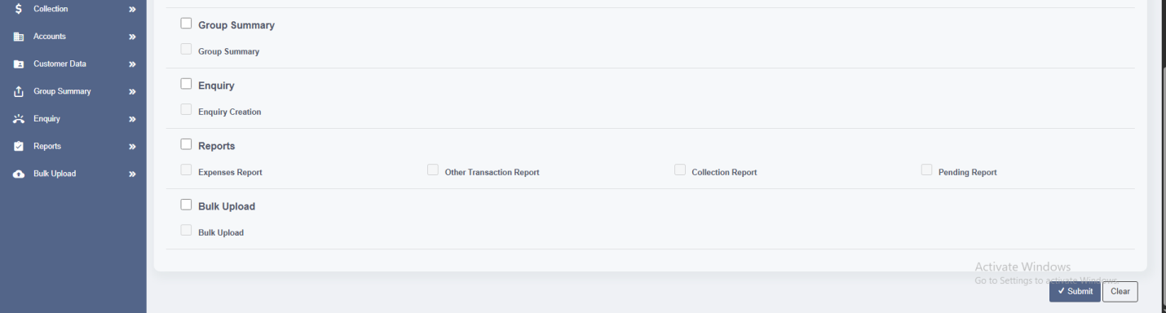

* The **Add Role** modal enables administrators to define and add new roles to the system. Roles are essential for managing user permissions and access levels, allowing for customized control over what different users can see and do within the software.

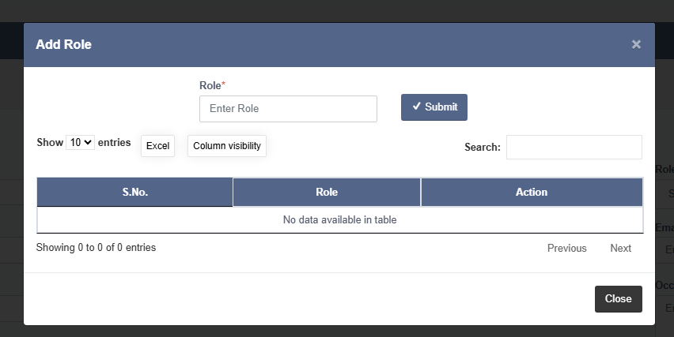

* The **Add Place** modal is a component of the user creation and management functionality within Chit Software. It enables administrators to define and manage places (or locations) within the system. These places could represent different geographical locations, offices, or any other relevant place that needs to be tracked or selected in the software.

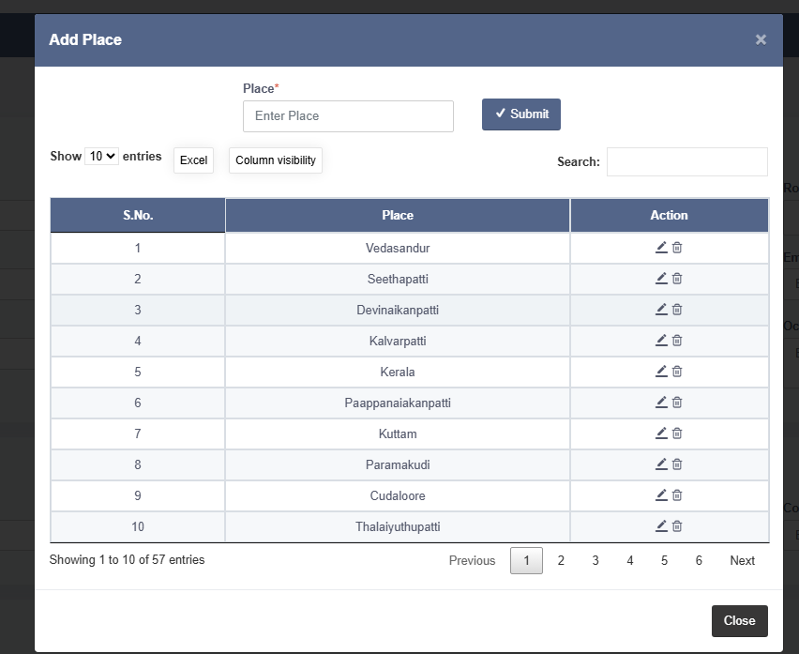

* The **Add Designation** modal is an essential feature of the User Creation screen within the chit software. It facilitates the addition and management of specific job titles or roles (designations) that users can be assigned to within the system.

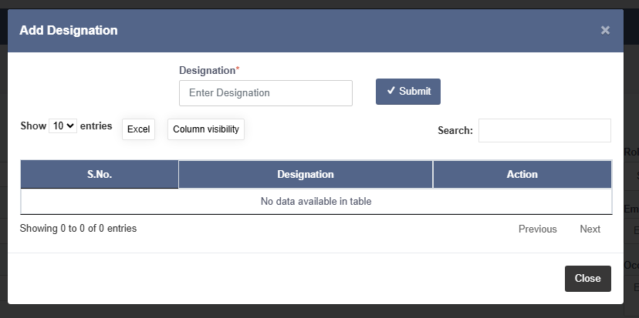

**4. AUCTION**

* The **Auction Creation** screen is a critical component in Chit Software, designed to manage and execute auctions for various chit groups. This screen facilitates the auction process by allowing users to view auction details, manage customer bids, and determine the chit value awarded to customers based on their bids.
* It enables the organization and execution of auctions for different chit groups, ensuring that the process is managed systematically.
* It Manages customer bids and determines the chit value based on the highest bid, ensuring fair and transparent auction results.
* During the auction, customers place bids within the defined low and high values. The customer with the highest bid is considered for receiving the amount.

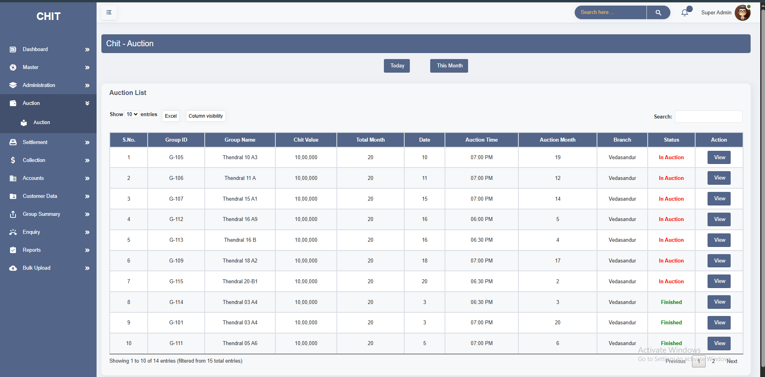

* This section records and displays monthly auction results for a specific chit group including details of participants and winning bids.

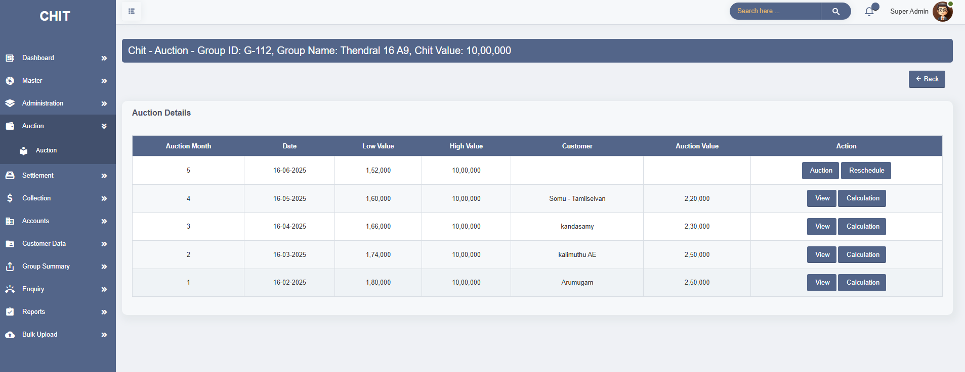

* The **Auction** modal displays all essential group-level information such as Group ID, Group Name, Branch Name, Chit Value, Auction Month, Auction Date, and Value Range. This ensures the admin has complete context before initiating the auction. User can select eligible customers, add them to the auction list, and input their bid values. This enables real-time tracking of participants and their auction amounts. The module provides dedicated controls for **"Auction Start"** and **"Auction Close"**, ensuring proper initiation and conclusion of the auction event, thus enforcing process discipline. When the **"Auction Start"** button is clicked **before the scheduled time**, the system displays a warning. The bid value cannot exceed the **High Value** If two customers enter the **same bid**, it show warning.

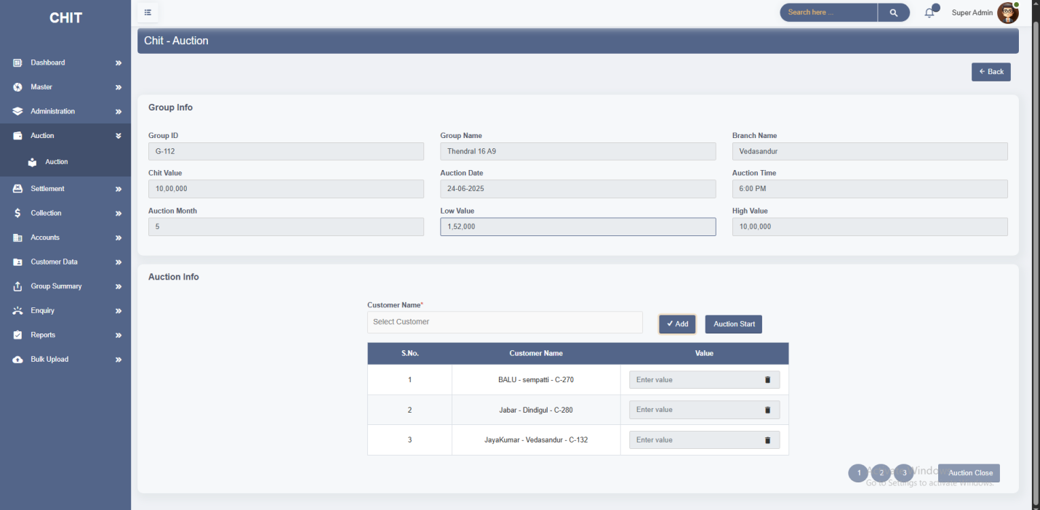

* The **Auction Reschedule** modal serves the crucial function of allowing users to postpone a scheduled auction to a new date. This feature is necessary when unforeseen circumstances arise, requiring the auction to be delayed. By using this modal, administrators or authorized users can select a new date for the auction, ensuring that the process remains organized and that all participants are properly informed of the change.

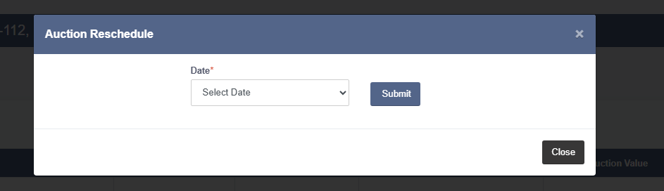

* The **View Modal** serves as a tool to display detailed information about the bids placed by customers during an auction. This feature is crucial for reviewing and verifying the bids submitted by each customer, ensuring transparency and accuracy in the auction process. It helps administrators and users to quickly assess which customers participated and the values they bid and it highlight the winner of the bid.

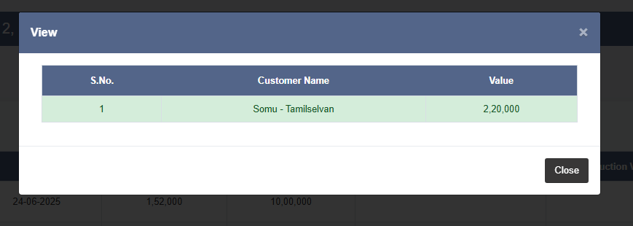

* The **Calculation Modal** display the detailed financial calculations related to a specific auction. This modal provides a summary of the auction's financial aspects, including the chit value, auction value, commission, and the resulting amounts. It is crucial for verifying the financial outcome of the auction, ensuring that the amounts are correctly calculated and recorded.

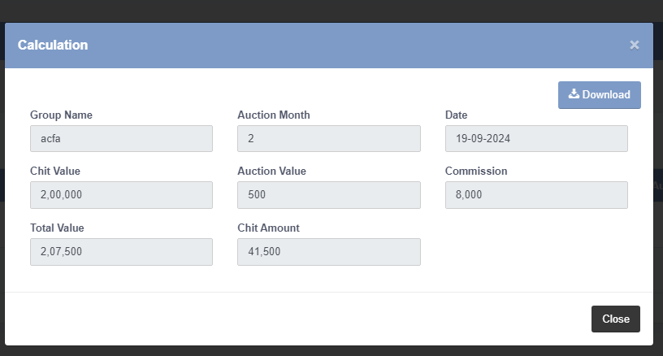

**5. SETTLEMENT**

* The **Settlement Screen** in chit software is designed to facilitate the final payment process for a customer who has won the auction. This screen is crucial for managing and documenting the disbursement of the chit amount to the winning customer. The settlement process ensures that the customer receives their entitled amount after all deductions (such as commissions) have been accounted for.
* The option to split payments across different methods (cash, cheque, bank transfer) allows the organization to cater to the preferences of the customer and the logistical needs of the payment process.
* The Settlement Screen ensures that the disbursement of the chit amount is handled accurately. It accounts for all necessary deductions, payment methods, and guarantor acknowledgments.
* Once all details are entered and verified, the settlement is processed, and the customer's chit amount is disbursed according to the chosen payment method and based on the share value recorded in the customer mapping.

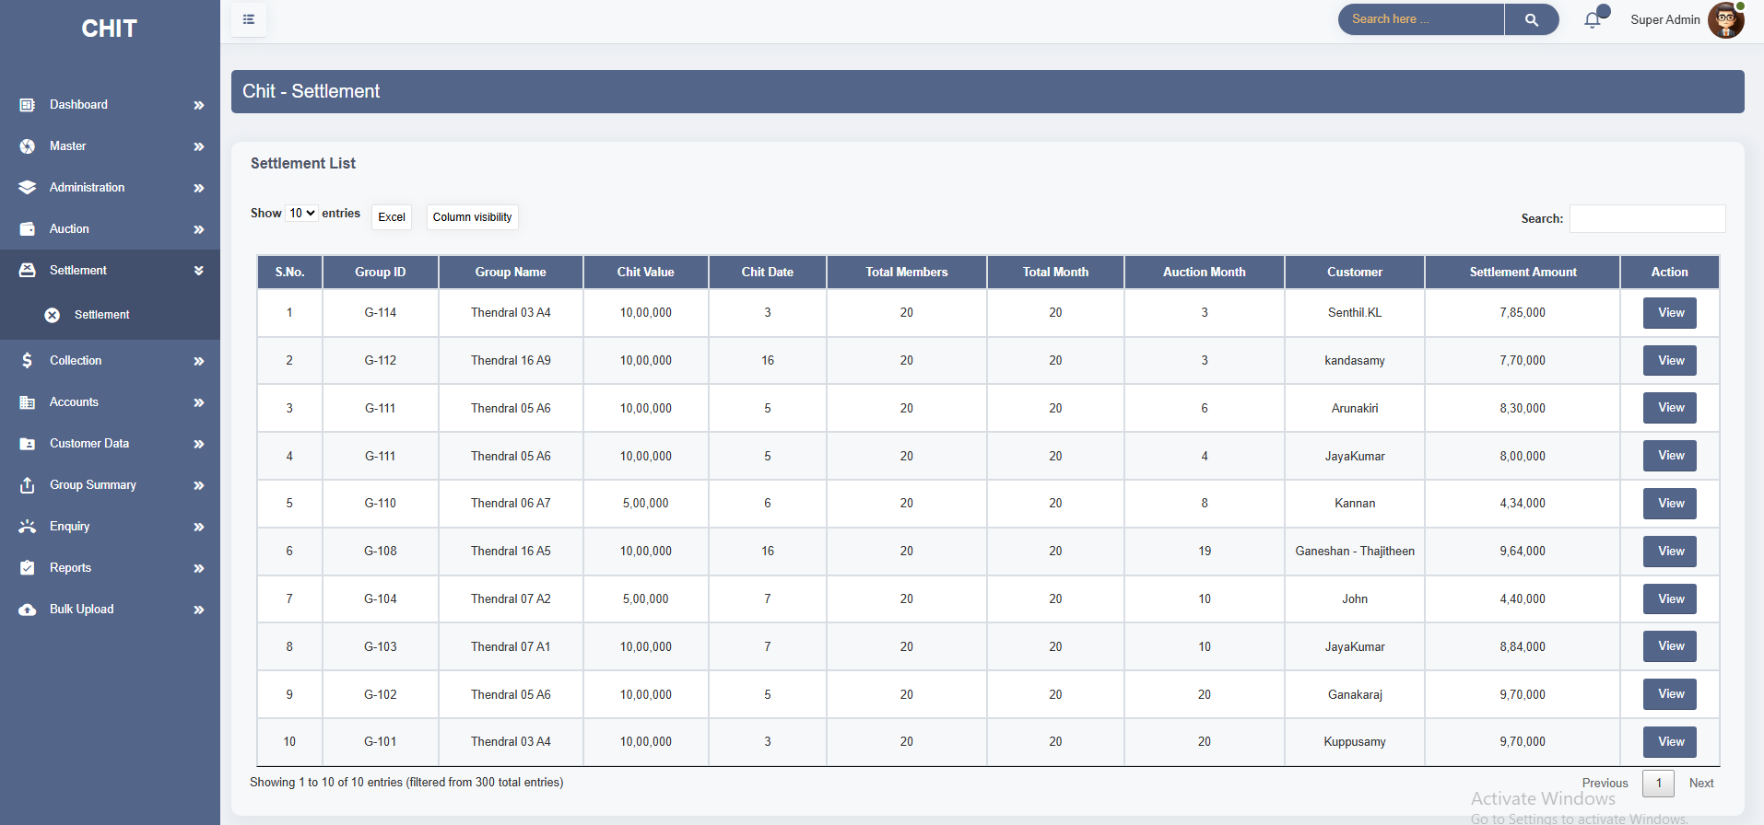

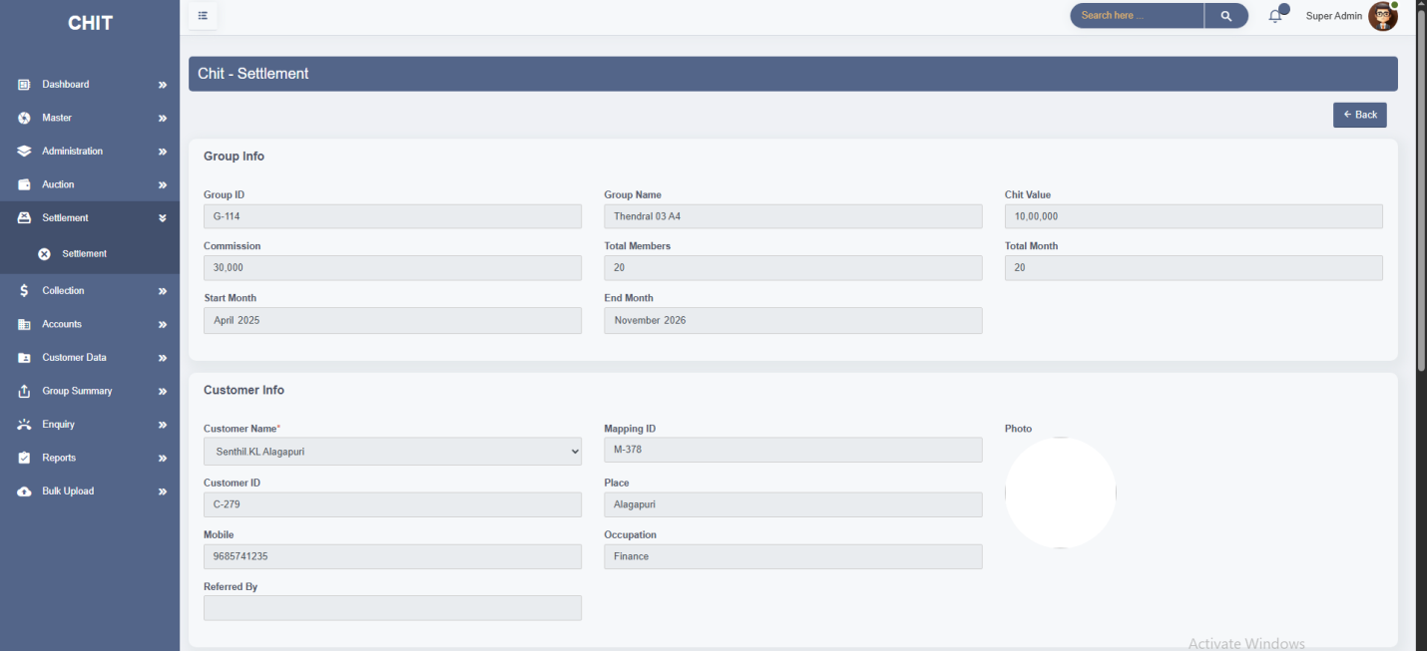

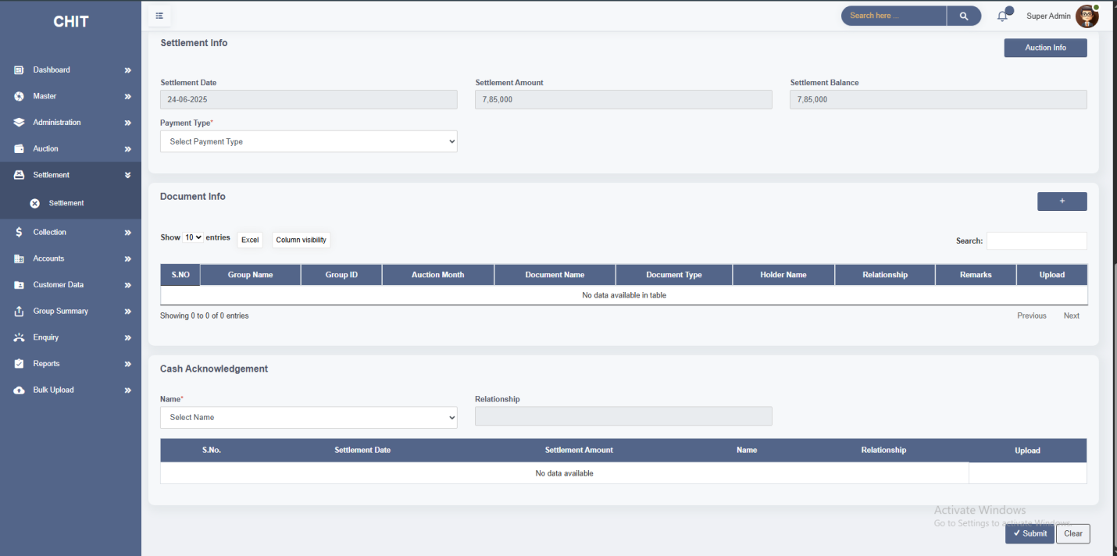

The **Add Document Info** module is designed to capture and store important documents related to a specific chit group and auction month. It ensures that all customer or guarantor-related documents are securely uploaded and associated with the correct group share and auction cycle.

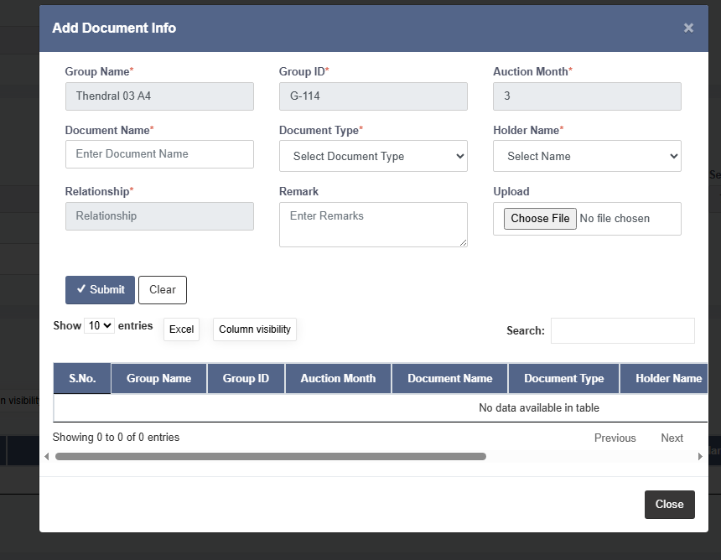

* The **Auction Info** display the detailed financial calculations related to a specific auction. This modal provides a summary of the auction's financial aspects, including the chit value, auction value, commission, and the resulting amounts.

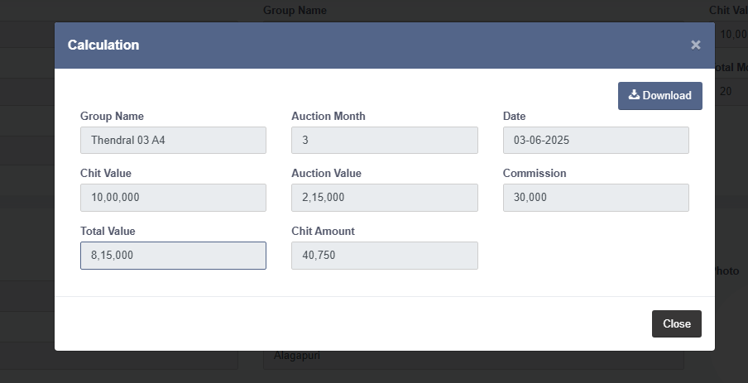

**6. COLLECTION**

* The **Collection Screen** is a critical component in chit fund software, designed to manage and track the collection of payments from customers. It allows users to monitor the status of each customer’s payments, manage grace periods, and ensure that collections are completed according to schedule.
* It helps in tracking which customers have paid and which have not, ensuring that all payments are collected timely.
* It grace period visual indicators help in quickly assessing whether payments are made within or beyond the grace period, which is crucial for managing late fees and customer follow-ups.
* The **Chit Amount** is calculated based on the customer’s **share percentage** as defined in the **Customer Mapping** module.
* The **Payable** field dynamically updates based on the customer’s share percentage and previous payments, ensuring accurate calculation of the outstanding amount. User can enter the Collection Date, select the appropriate Collection Mode (e.g., Cash, Bank Transfer), and input the amount received during the current transaction.

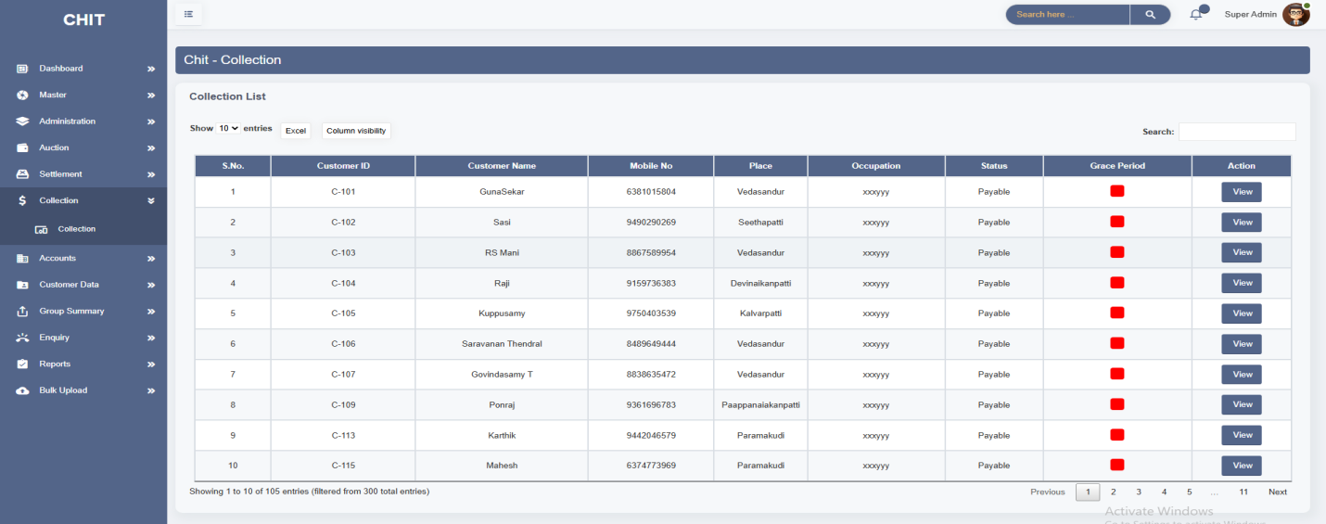

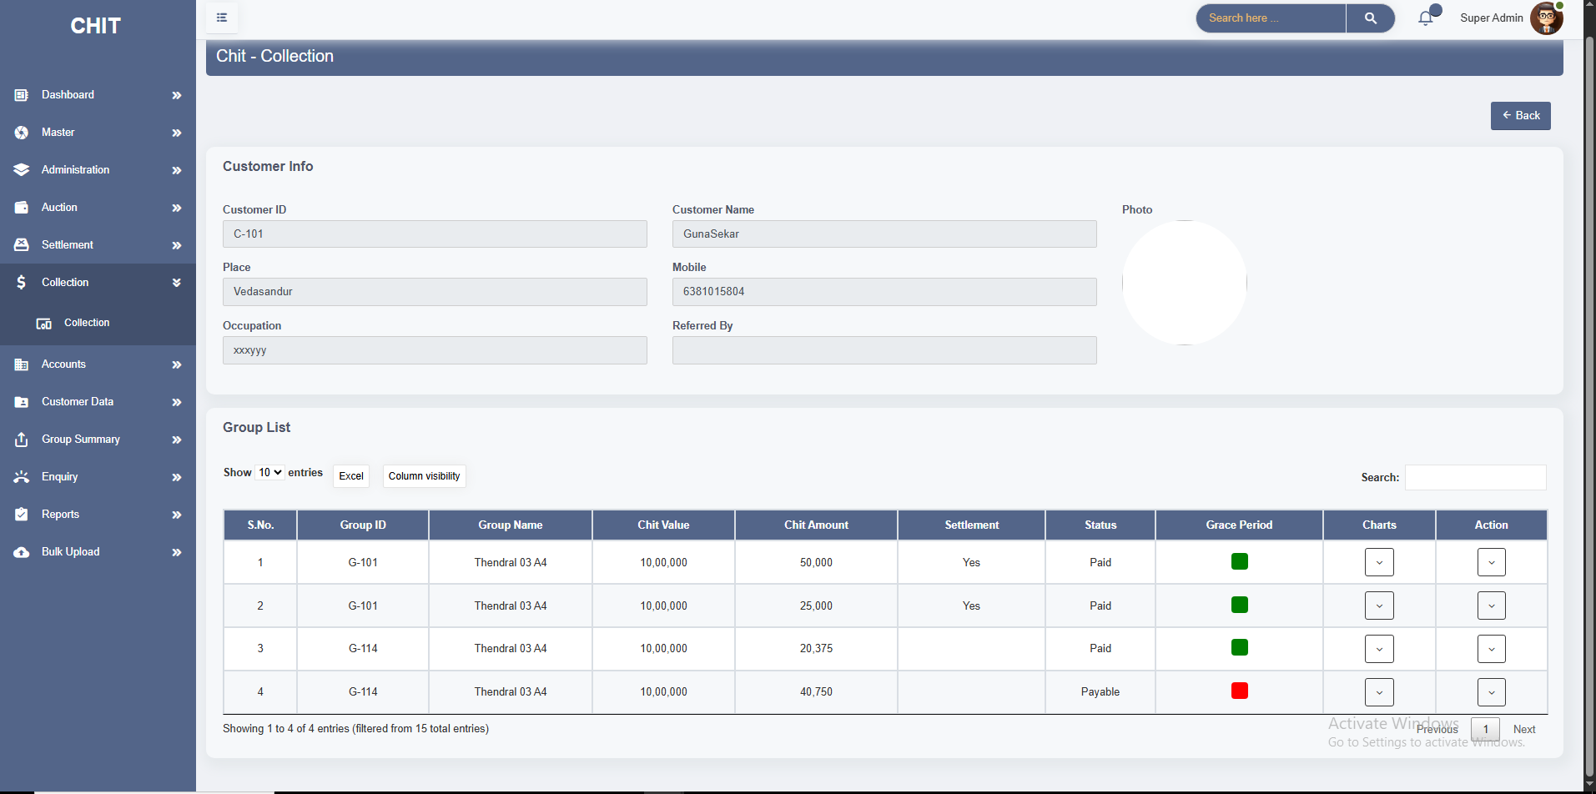

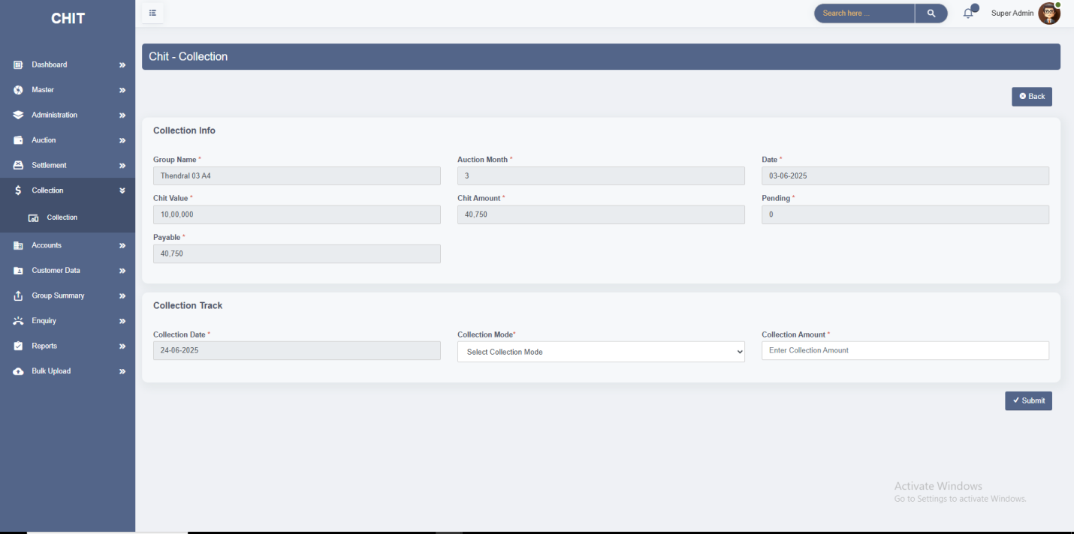

* The **Add** **Commitment** and **Commitment Chart** functionalities within the Collection Screen designed to manage and track commitments made by customers regarding their payments.
* It allows users to enter and record customer commitments related to their payments.
* It provides a visual representation of commitments, helping users to analyze and manage them more effectively.

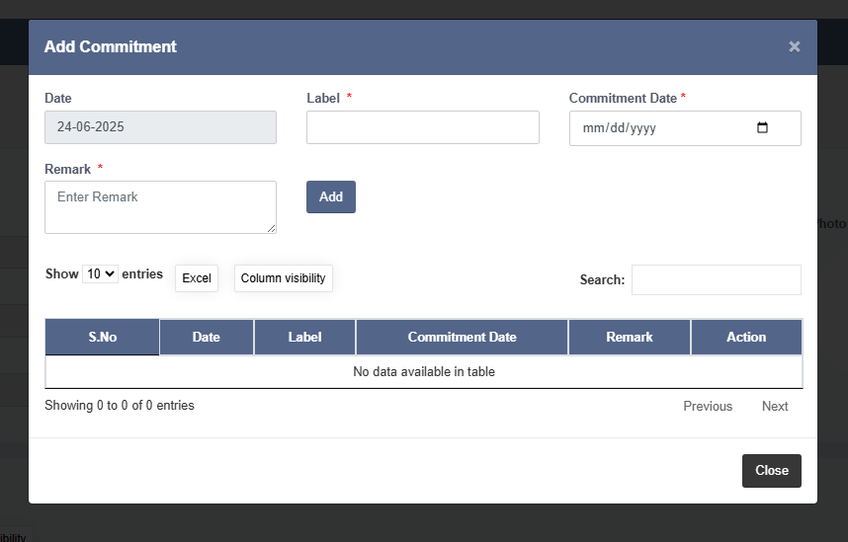

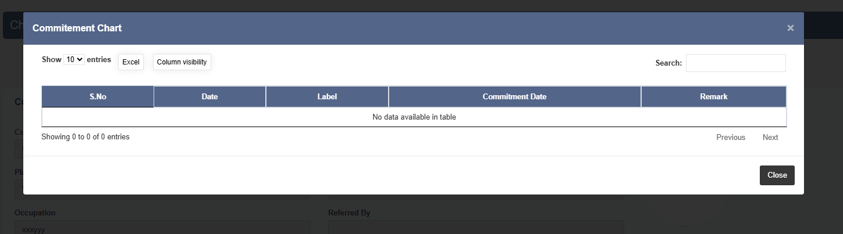

* The **Due Chart** in the collection screen tool for managing and monitoring outstanding payments and collections. It helps track the financial status of each chit, showing details about amounts due, amounts collected, the remaining balance and collection date.
* It helps in monitoring the financial status of each chit over time. The **print layout** is designed to be clear suitable for sharing with customers as a payment receipt or filing for audit purposes.

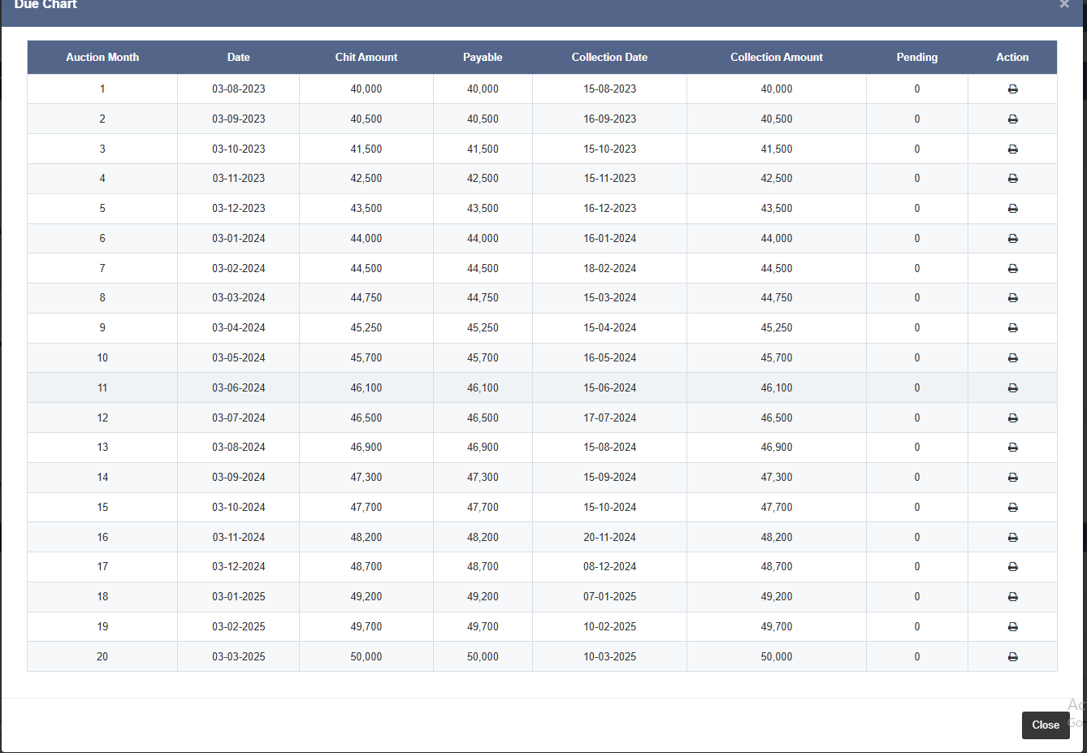

**7. ACCOUNTS**

* This module has 2 Screens. **1.Accounts, 2.Balance Sheet.**
* **Accounts:**
* The Accounts screen in the chit software is a vital tool used for managing financial transactions, collections, expenses, and other financial operations within the organization. It provides comprehensive functionalities to track and maintain financial records accurately.
* **Financial Tracking:** Tracks and monitors financial transactions, collections, settlement, expenses, and other transactions in real-time
* **Balance Management:** Manages opening and closing balances, hand cash, and bank cash to ensure accurate financial reporting and management.
* **Denomination :** used to capture the breakdown of hand cash available at the end of the day This module supports **day-wise tracking** with options to view either **"Previous Day"** or **"Today".**

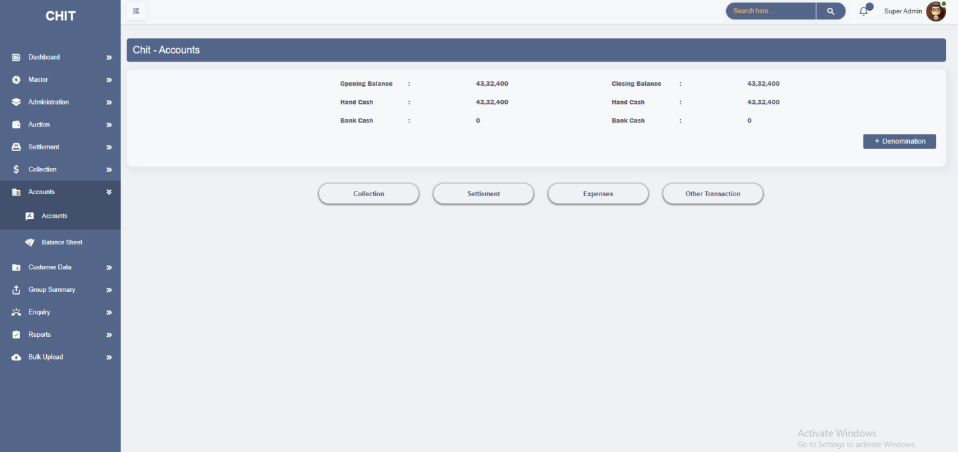

* The **Collection** section within the **Accounts** screen helps to track the incoming cash flows from various sources and ensures accurate accounting of collections.
* It keeps track of collections made by users at different branches and helps monitor and evaluate the performance of different branches and users in terms of collections.

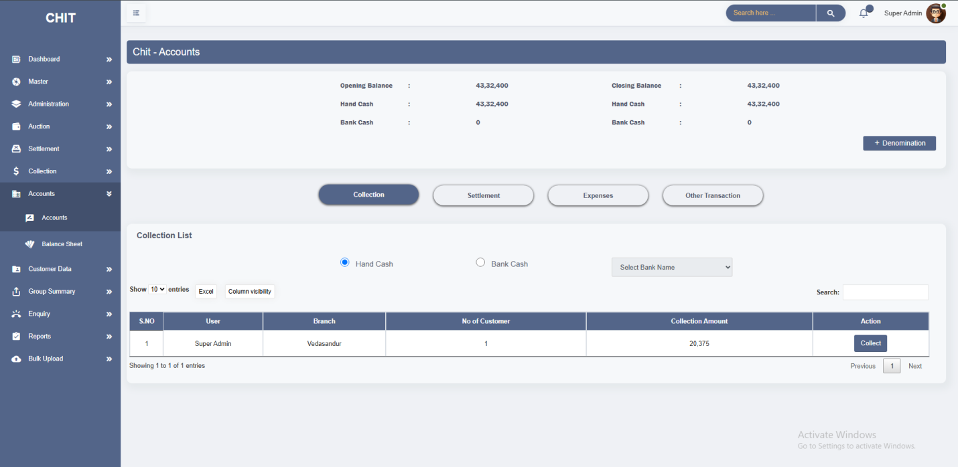

* The **Settlement** section in the **Accounts** screen shows detailed information about settlements made, including who handled them and the amount settled.
* It differentiates between hand cash and bank transactions for effective cash management.

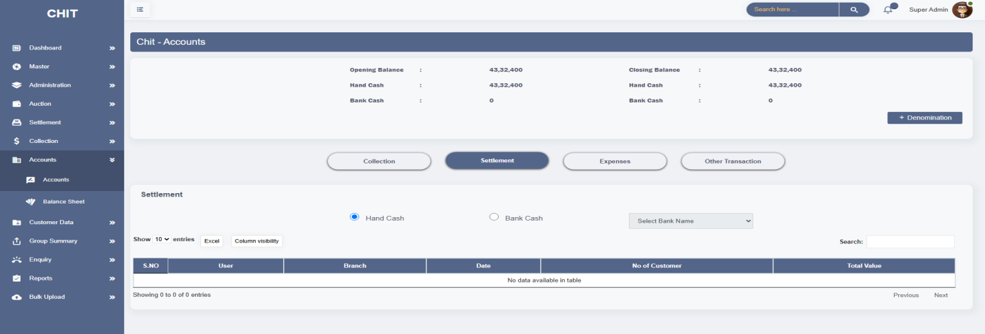

* The **Expenses** modal in the **Accounts** screen is designed to track and manage expenditures related to the operation of the chit software system.
* It helps in recording and categorizing expenses, providing insights into the financial outflow, and ensuring proper accounting for operational costs.
* It enables users to input detailed information such as invoice ID, branch name, expense category, description, amount, and transaction ID for each expense incurred.
* **It restricts expense entries from exceeding the available closing balance**. If a user attempts to debit an amount greater than the current hand cash or closing balance, the system will block the action and display an alert.

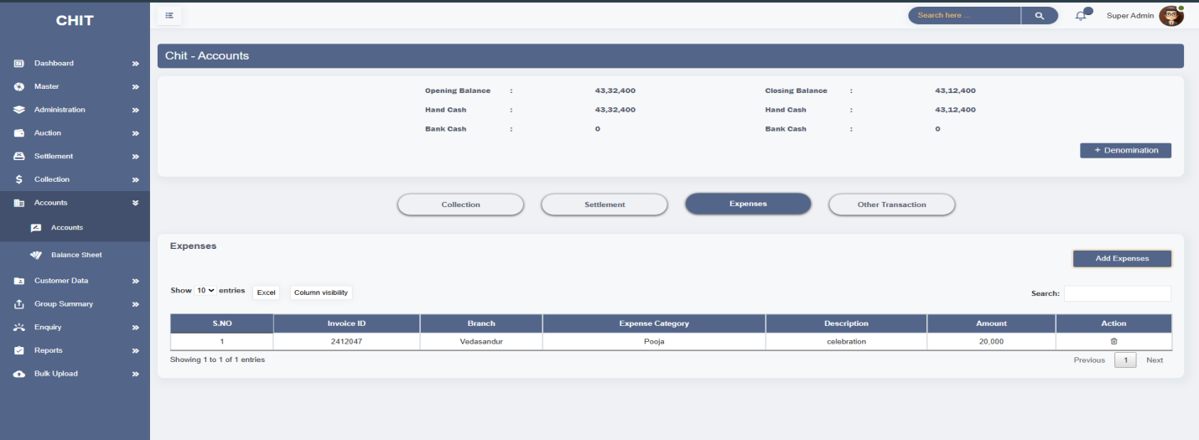

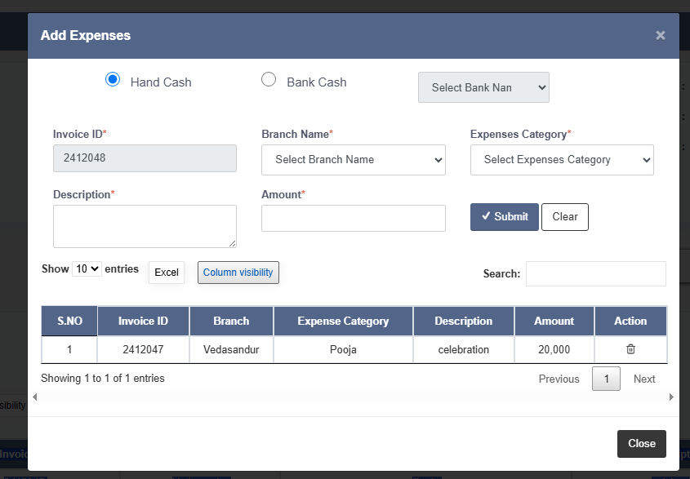

* The **Other Transaction** modal in the **Accounts** screen is designed to manage and record various types of transactions that do not fall into standard categories like collection, settlement, or expenses. This feature allows for tracking miscellaneous financial activities, ensuring all financial operations are accurately documented and accounted for.
* It handles various other financial transactions such as deposits, credits, debits and investments and chit Advance etc.

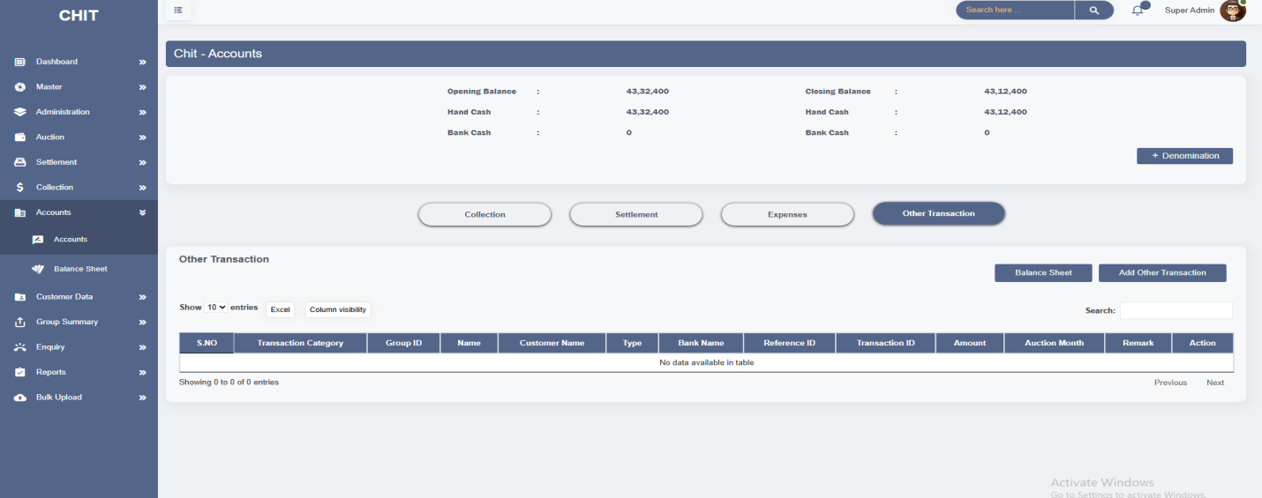

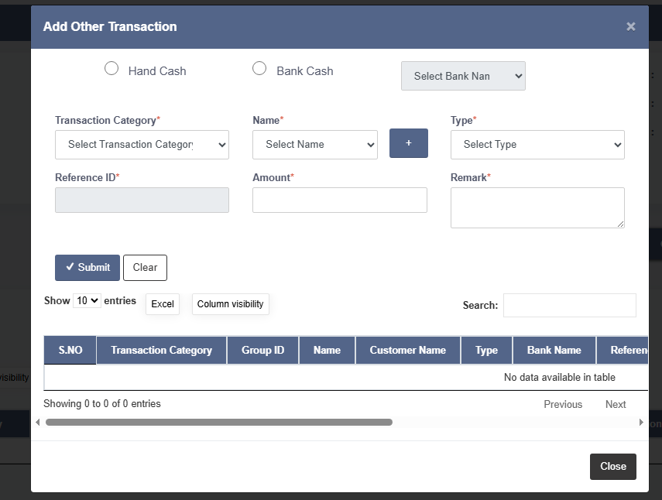

* The **Balance Sheet** feature within the **Other Transaction** modal is crucial for tracking and documenting financial movements and ensuring accurate accounting in a chit software system. This tool helps users to monitor the cash flow, reconcile discrepancies, and maintain an updated view of financial status.

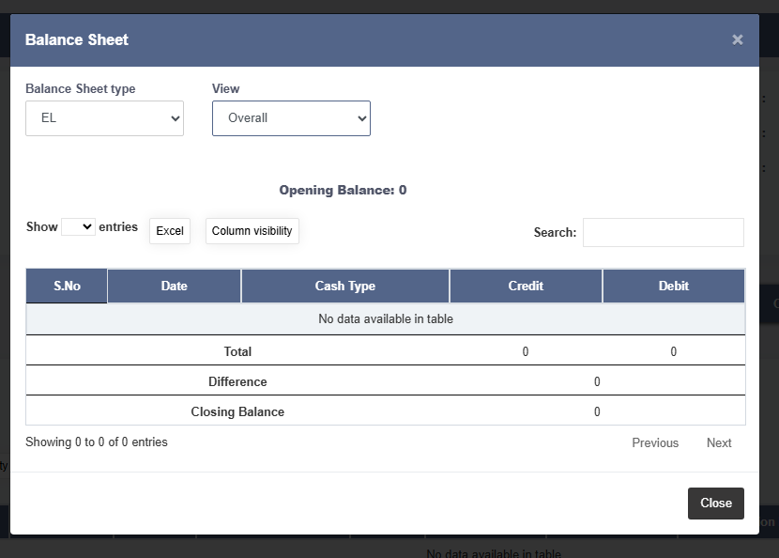

* **Balance Sheet:**
* The **Balance Sheet** in the **Accounts Screen** of chit software provides a detailed overview of the financial status for a given period. It helps in tracking various financial transactions, summarizing income and expenses, and providing a snapshot of the financial position.
* It allows users to analyze the net benefit or loss during the period, helping in financial planning and decision-making. The module includes a **user selector dropdown**, allowing the admin to generate balance sheets specific to a user or operator

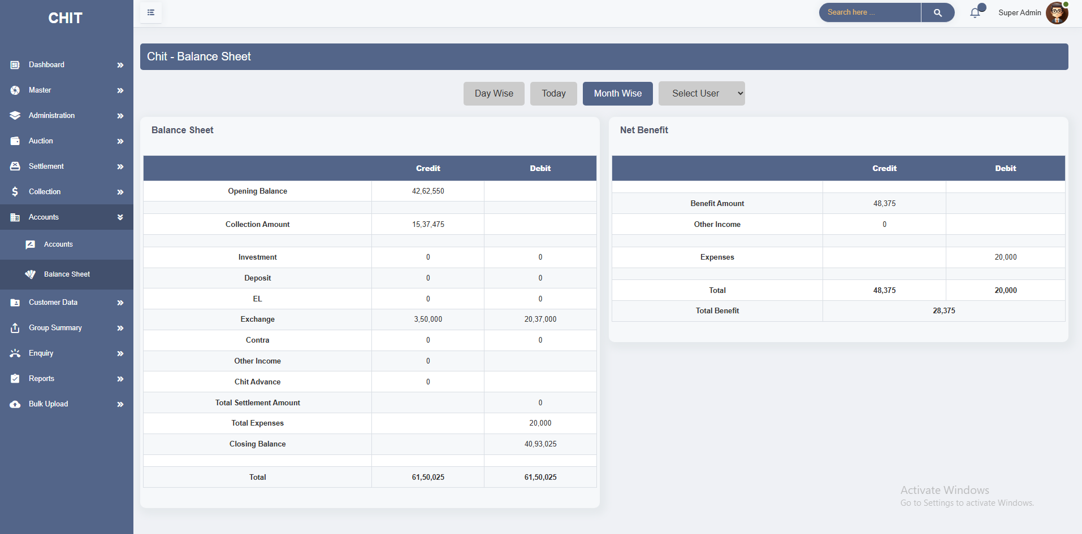

**8. CUSTOMER DATA**

* The **Customer Data** section in chit software is a crucial component for managing and maintaining detailed records of all customers involved in the chit fund. This section is used to store, retrieve, and update comprehensive customer information, ensuring that all necessary details are easily accessible and up-to-date.

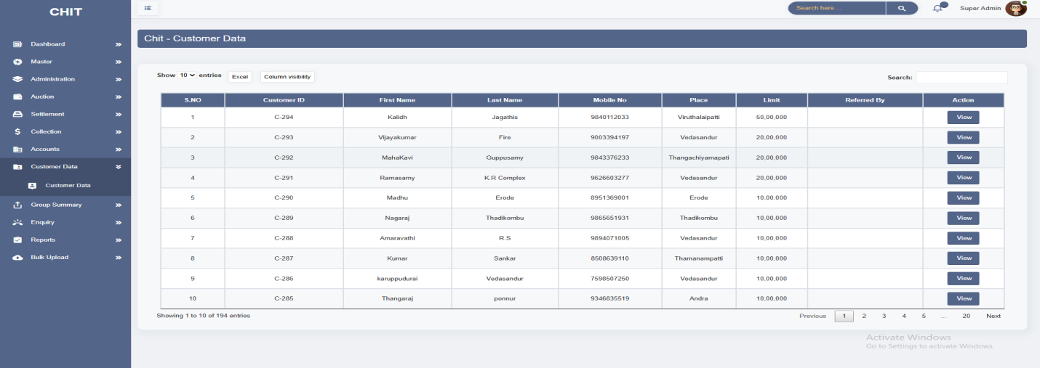

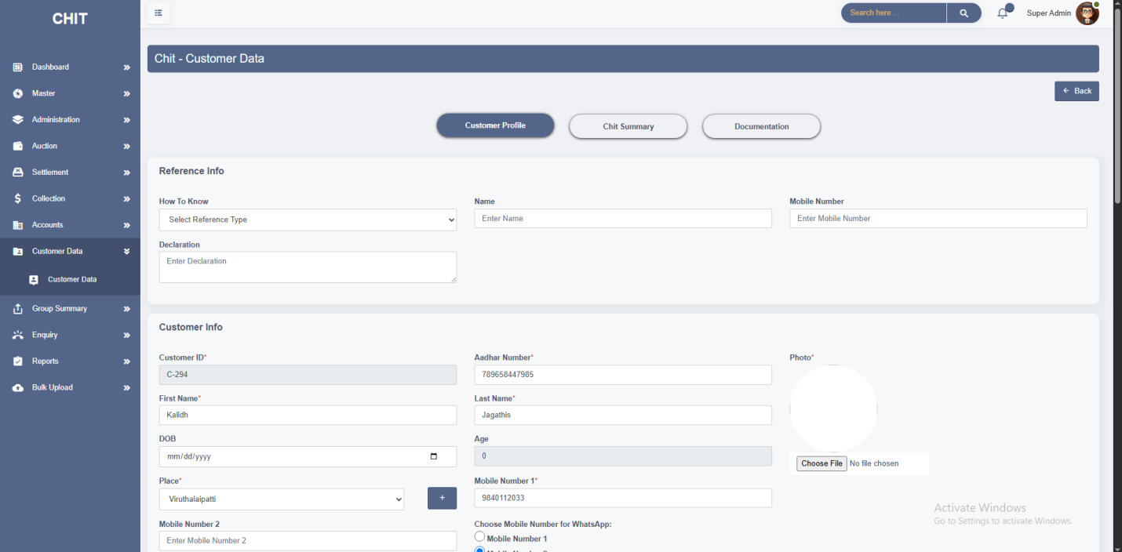

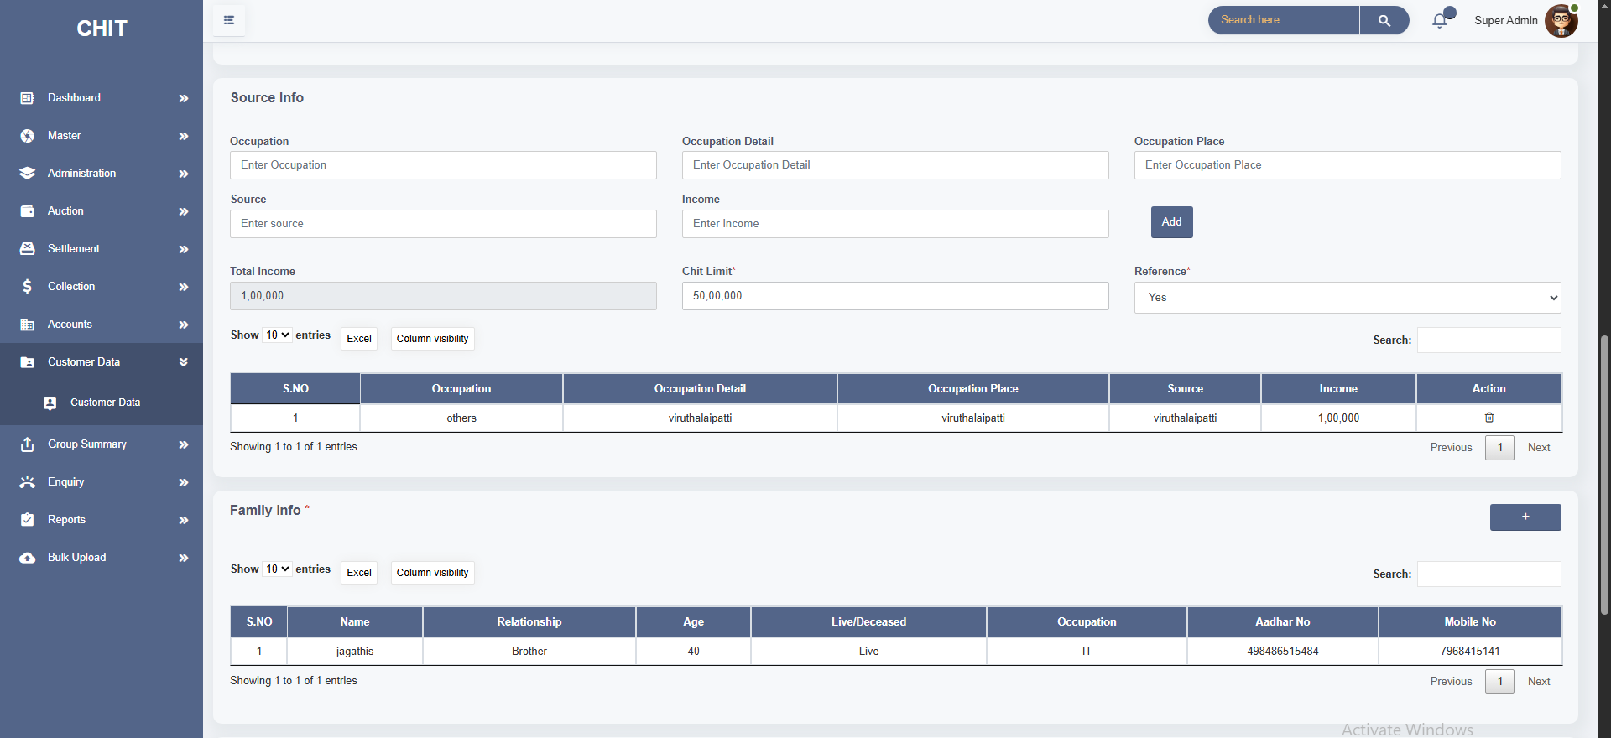

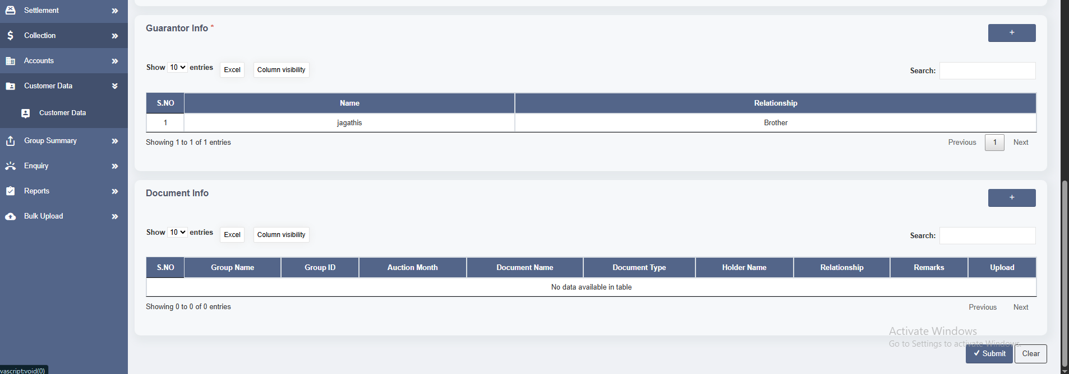

* The **Chit Summary** section in chit software provides a comprehensive view of a customer's participation across different chit groups. It is designed to give a quick snapshot of the customer’s involvement in various groups, whether they are currently active or have completed their obligations.
* It shows whether the chit group is currently active ("Current") or has been completed ("Closed"). This helps in differentiating ongoing obligations from those that have been fulfilled.
* It indicates the current status of collections within the group, such as "In Collection" or "Completed," providing insight into the group's financial activities.

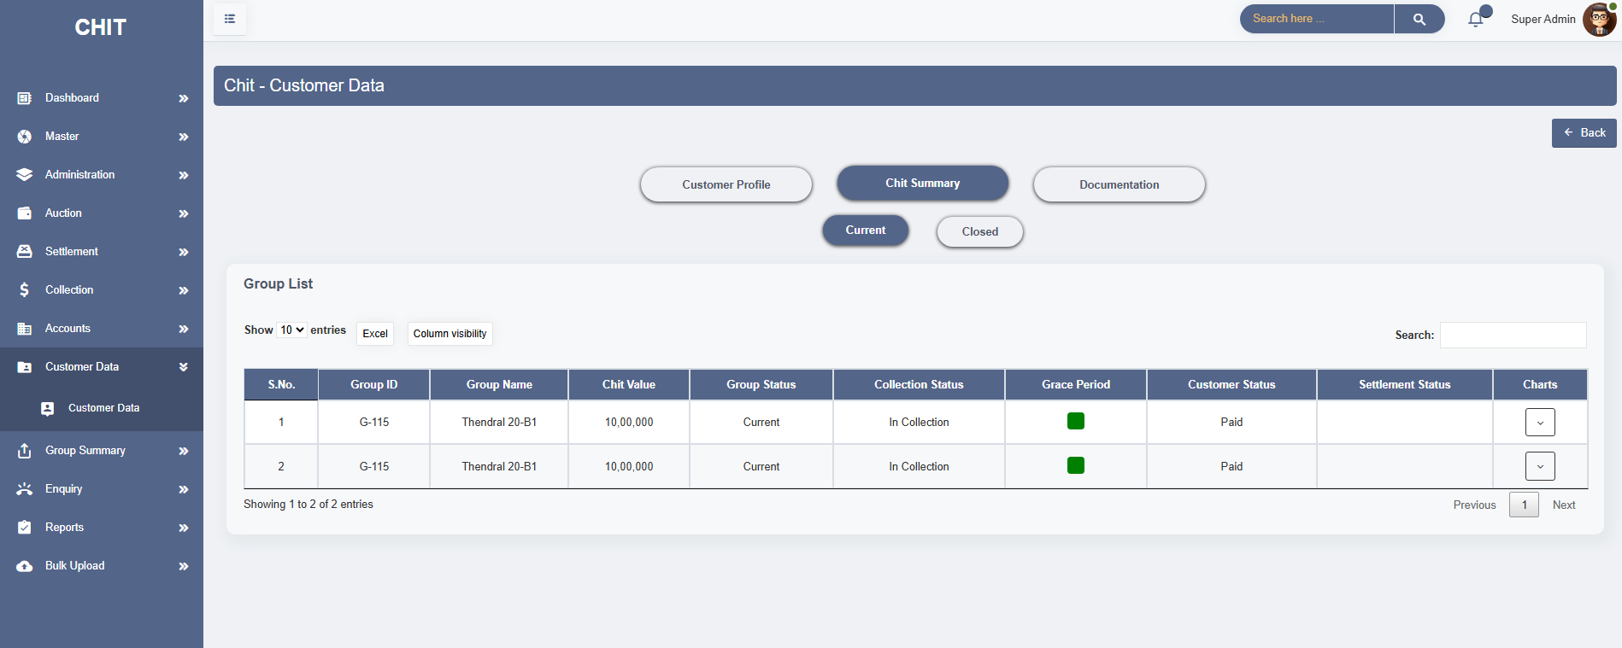

* The **Documentation** within the **Customer Data** module is designed to display all documents submitted by a customer across various chit groups. It acts as a centralized repository for retrieving and verifying customer-related files such as ID proof, address proof, photos, and any documents uploaded during the settlement process.

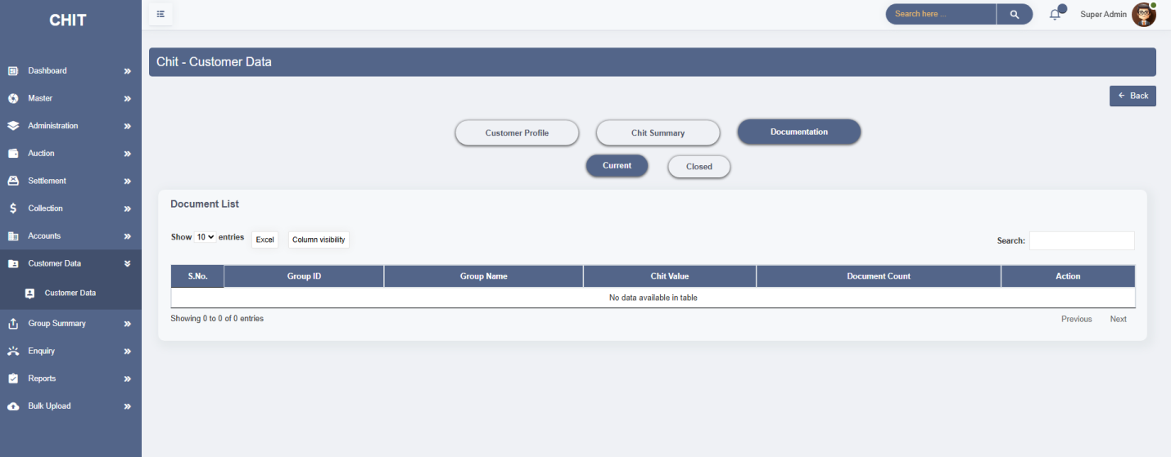

**9. GROUP SUMMARY**

* The **Group Summary** section in chit software provides a detailed overview of all chit groups managed within the system. It offers insights into each group's status, collection activities, and auction results. This section is crucial for tracking the progress and financial health of each chit group.
* It allow users to toggle between viewing only "**Current**" groups (active chit groups) or "**Closed**" groups (completed chit groups). This filtering is useful for focusing on relevant groups based on their status.
* It lists the auctions conducted within a group, including columns like Auction Month, Date, Auction Value, Customer, Auction Status, Group Status, and Collection Status.
* It indicates the outcome of the auction (e.g., "Finished," "In Auction"), showing whether the auction process has been completed or is ongoing.

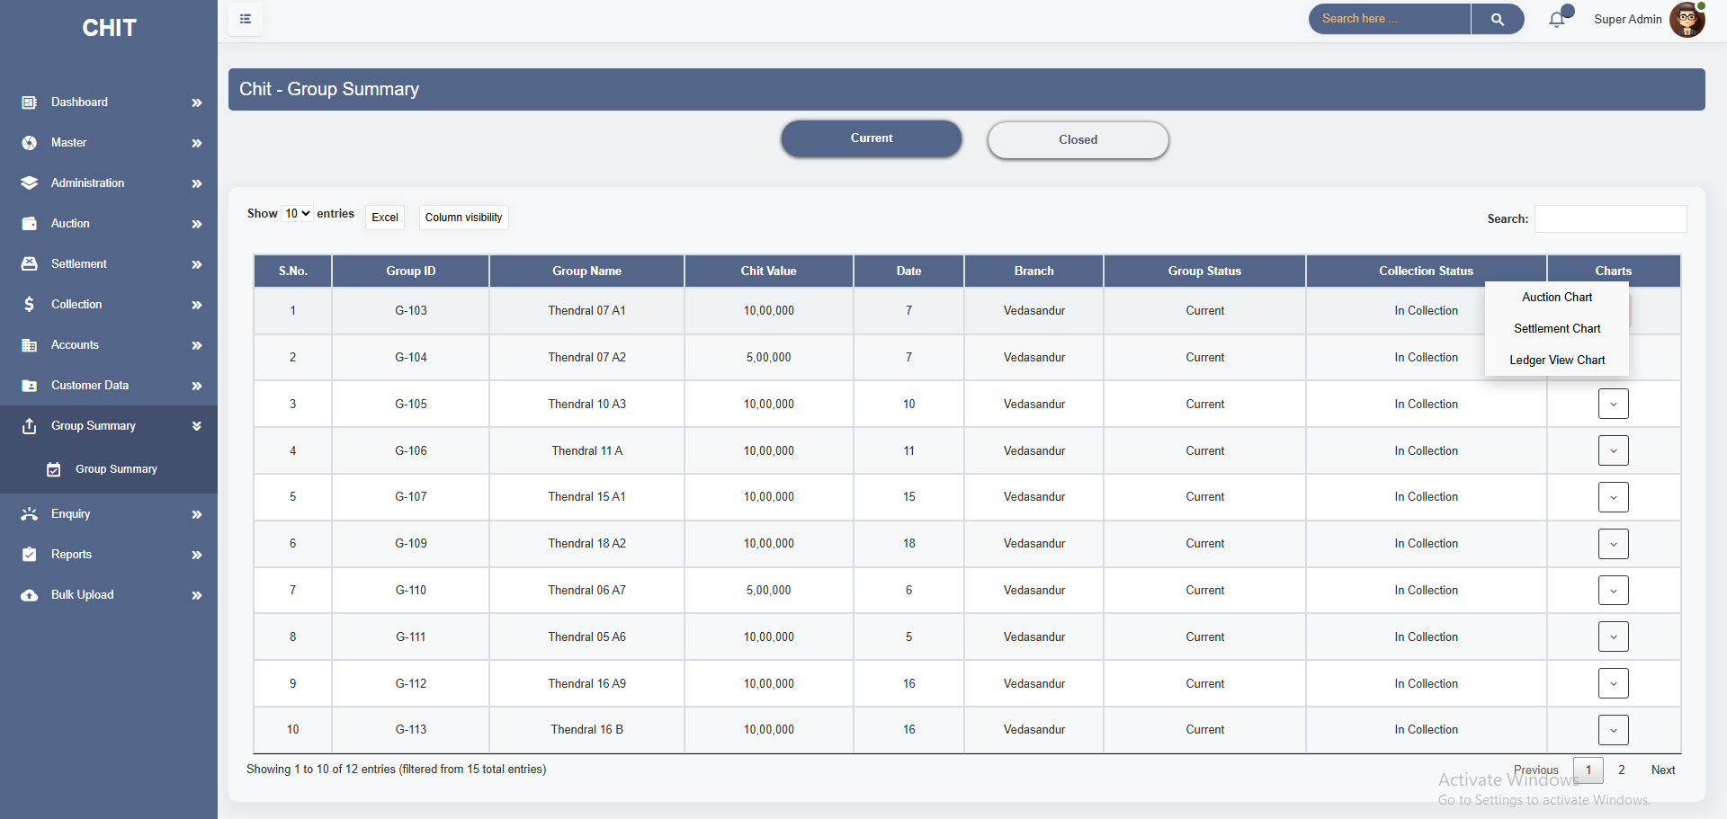

* The **Auction Chart** in the Group Summary section of chit software provides detailed information about the auctions held within a specific chit group. This chart is essential for tracking the financial aspects of each auction, including the auction value, commission, and the total amount involved. It is particularly useful for administrators and group members to review the auction outcomes and understand the financial transactions for each auction cycle.

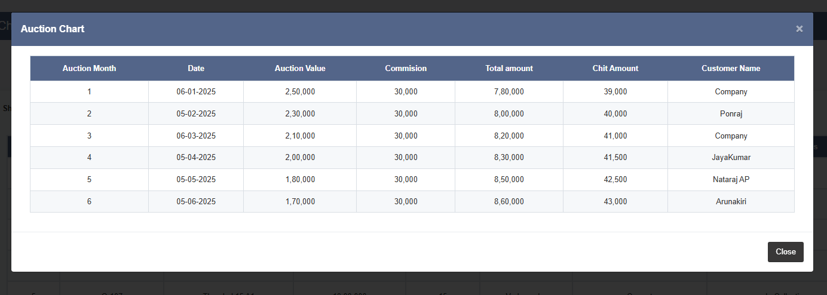

* The **Settlement Chart** provides a detailed view of the settlement transactions within a particular chit group. This chart is crucial for tracking the settlement of amounts owed to customers after auctions or during regular payouts.
* It helps administrators and group members understand which customers have received their settlements, the amounts involved, and the dates of these transactions.

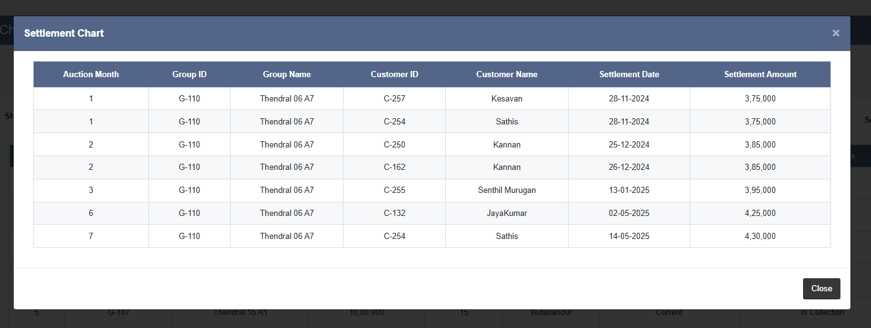

* The **Ledger View** module provides a structured view of customer-wise monthly contribution tracking for each chit group. It is primarily used to monitor installment payments, verify settlement status, and manage outstanding dues over the entire chit cycle.
* As payments are made, the system records the actual contribution per customer, month-wise. If a settlement has been completed for a customer, the **Settlement** column reflects "Yes," indicating full disbursement of that customer's chit value.

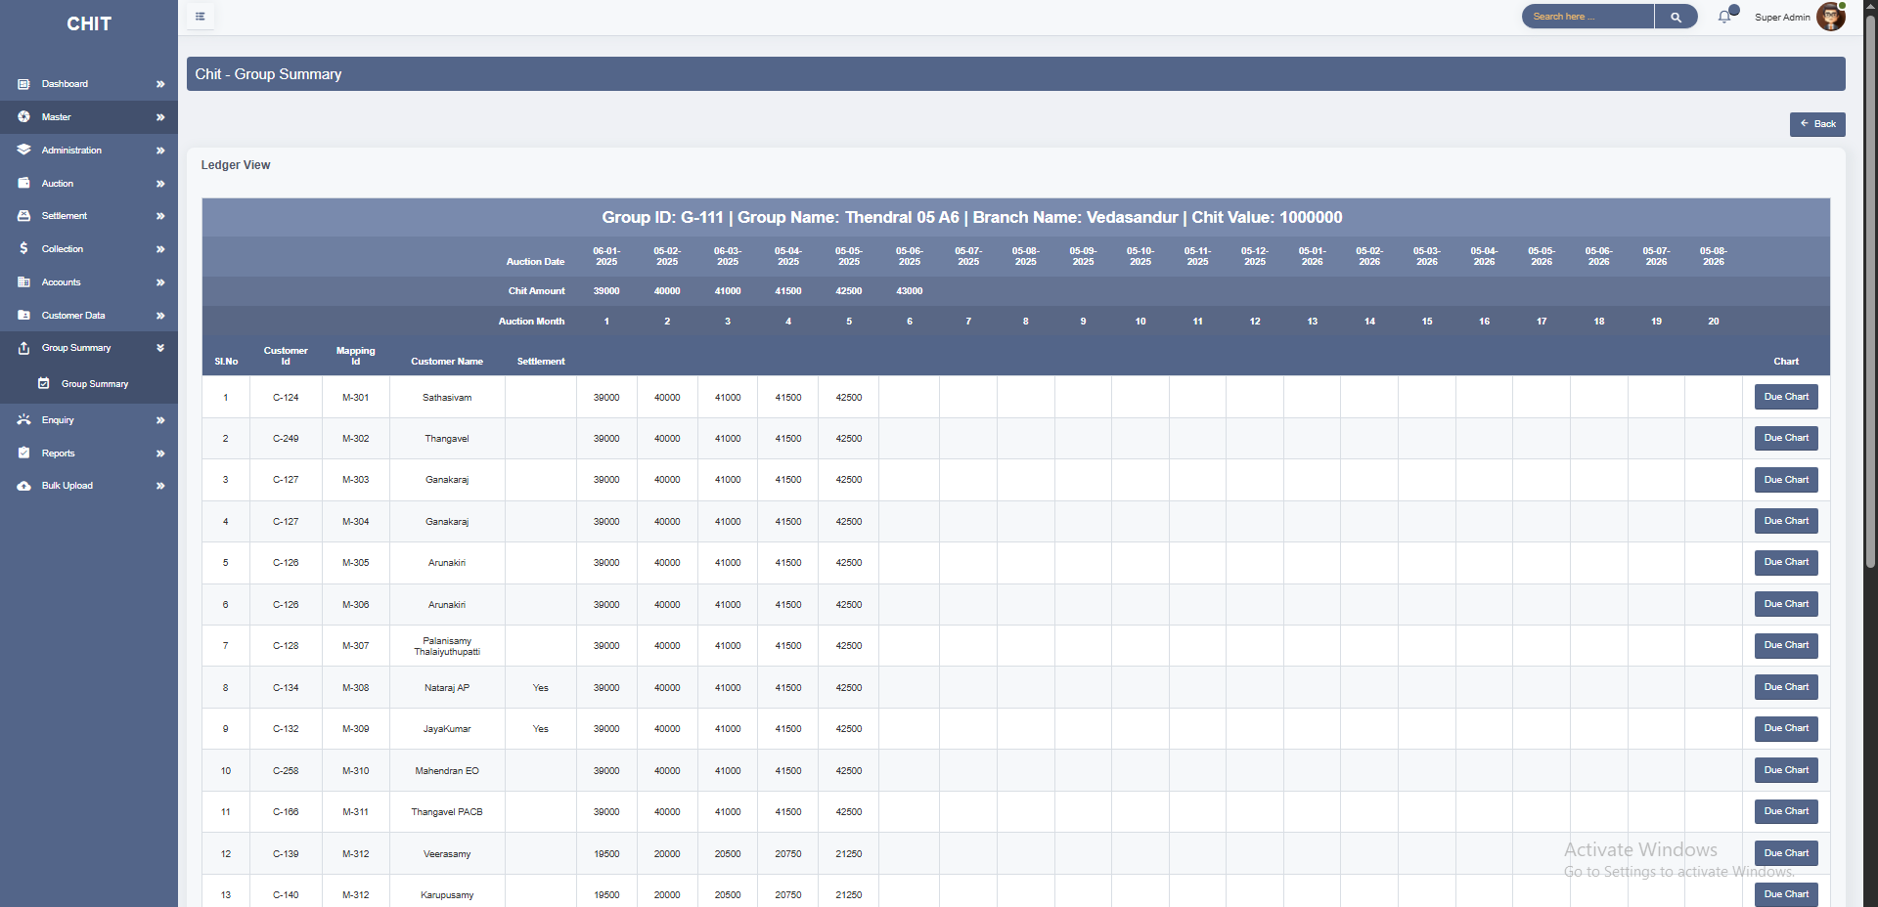

**10. ENQUIRY CREATION**

* **Enquiry Creation** in chit software is a feature that allows administrators or agents to capture and manage customer leads or inquiries. This module is crucial for documenting initial interest shown by individuals in joining a chit fund group.
* The process helps in organizing, tracking, and converting inquiries into active memberships, ensuring that no potential customer is overlooked.
* The chit value and duration fields allow the software to categorize and prioritize enquiries based on their financial significance.
* By recording basic information such as name, status, and place, the software helps in organizing leads, making it easier to manage and follow up on them.

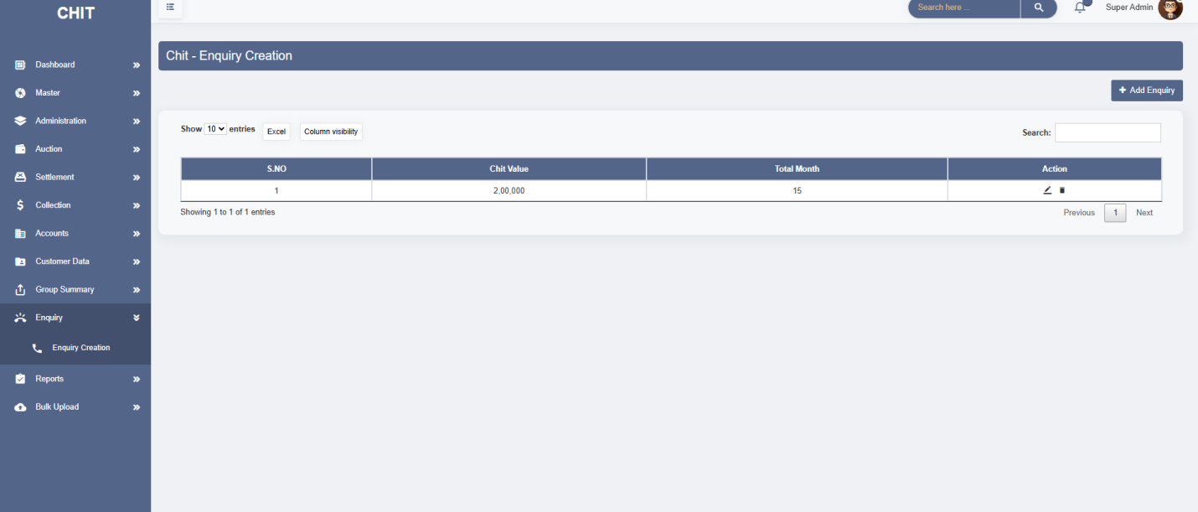

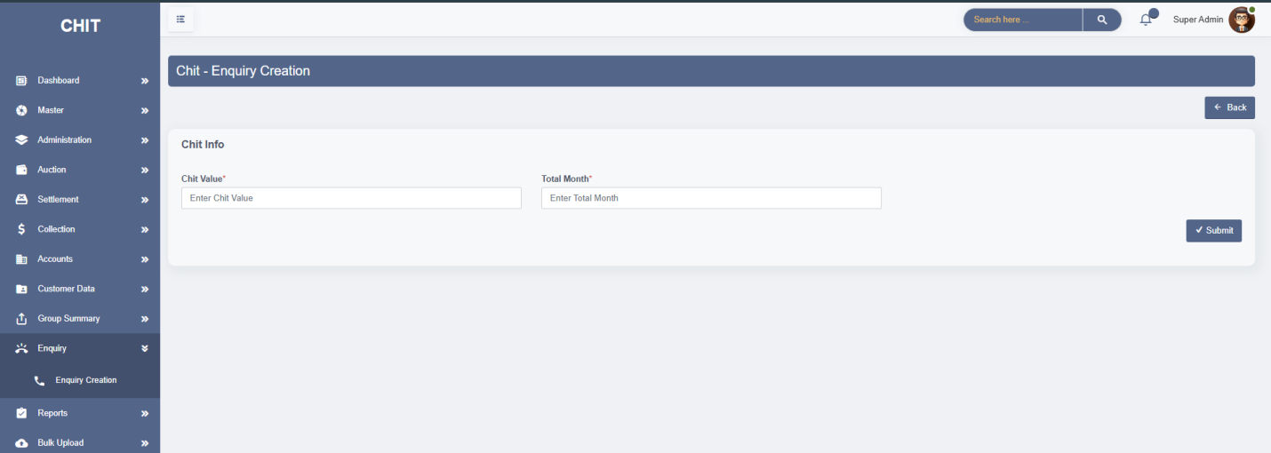

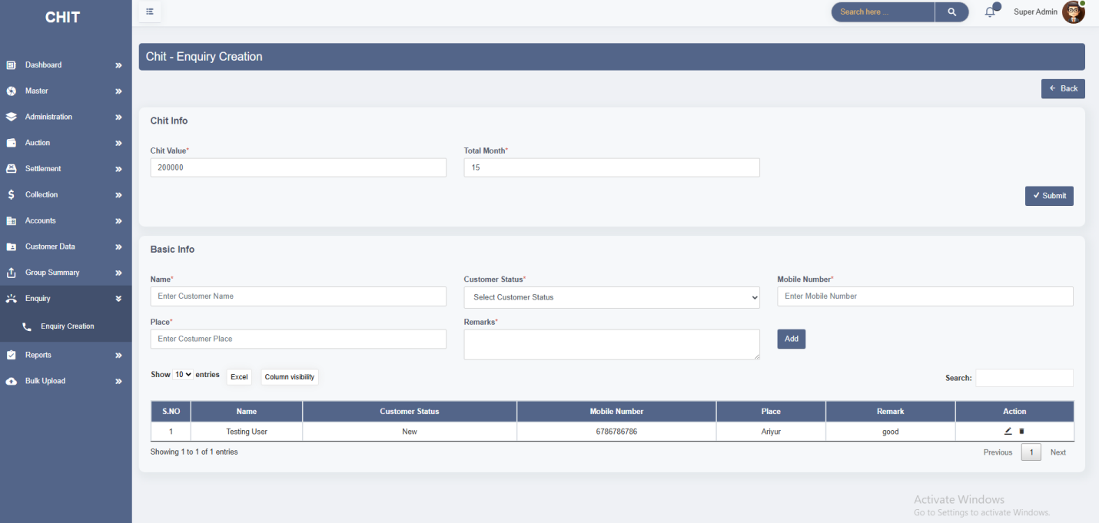

**11. Reports**

* This module has 4 Screens. **1.Expenses Report, 2.Other Transaction Report 3.Collection Report 4.Pending Report**
* **Expenses Report:**
* The **Expenses Report** module provides a detailed summary of all recorded expenses over a selected date range. It helps administrators and financial auditors track where and how funds are being spent across branches, categories, and transactions.
* Users can select a **"From"** and **"To"** date to generate a filtered report of all expense entries during that period. Once the report is generated, the system displays a list of individual expenses in a structured table.
* Each expense record is displayed with essential details such as the **Invoice ID**, **Branch**, **Expense Category**, **Description**, and the **Amount** spent.

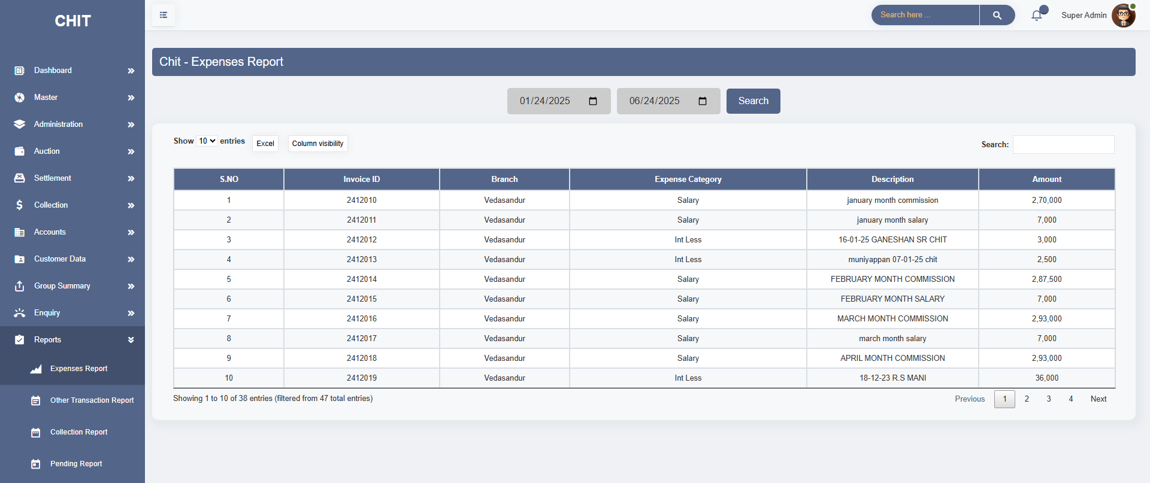

* **Other Transaction Report:**
* The **Other Transaction Report** module in the chit application provides a consolidated view of all non-collection and non-expense-related financial transactions, such as **Chit Advances**, **Exchange, Investment, El and Deposit Entries.**
* Users can filter the report by date range, such to view relevant transactions during that period. Each record is displayed with important attributes, including **Transaction Category** (e.g., Chit Advance or Exchange), **Group ID** (if applicable), **Customer Name**, **Transaction Type** (Debit or Credit), **Bank Name**, **Reference ID**, **Transaction ID**, **Amount**, **Auction Month**, and a **Remark** describing the context.

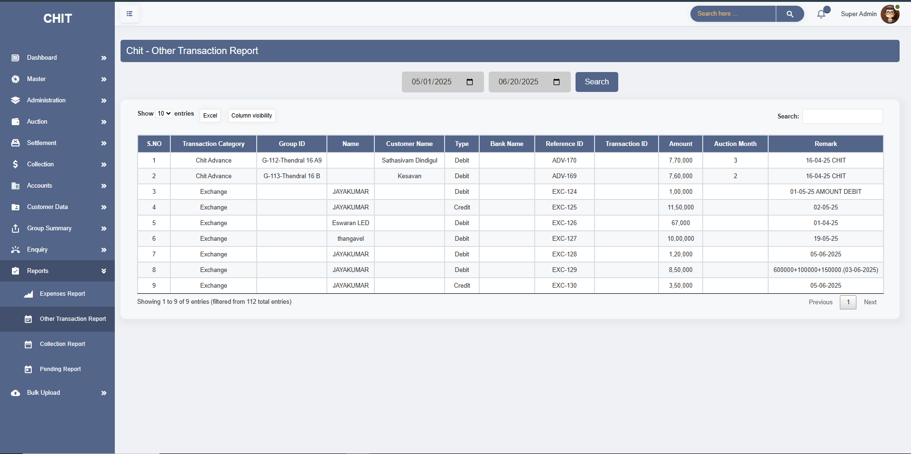

* **Collection Report:**
* The **Collection Report** module provides a detailed, date-filtered overview of all customer payment collections within the chit system.
* These reports is used by administrators and finance teams to track incoming payments from members, verify collection timelines, and ensure that each member’s contribution is recorded correctly against their assigned chit group and auction cycle.
* Users can specify a date range to view a list of all collections made during that period. Each entry includes key information such as **Customer ID**, **Customer Name**, **Place**, **Mobile Number**, **Group ID**, **Group Name**, **Auction Month**, **Collection Date**, and the **Collection Amount**.

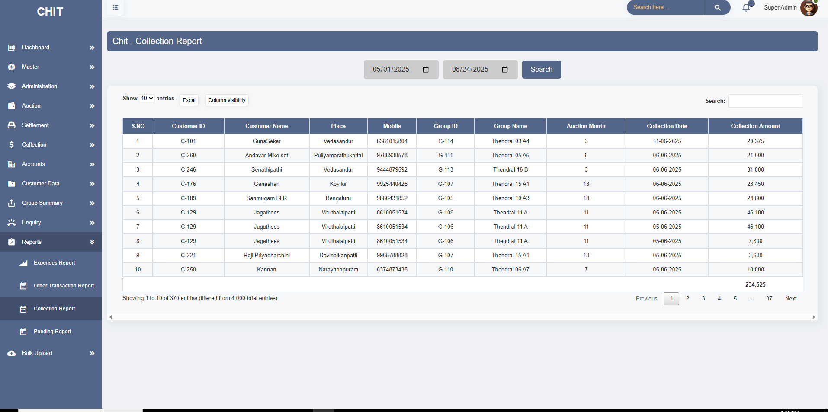

* **Pending Report:**
* The **Pending Report** module is designed to display a consolidated list of customers who have **outstanding dues from previous auction months**. It provides a snapshot of unpaid or partially paid amounts that were not cleared during their respective collection periods, helping administrators and finance teams prioritize follow-ups and ensure recovery.
* For a given date, the system filters and displays only those customers who still have **pending balances** as of that point in time. The report includes key information such as **Customer ID**, **Customer Name**, **Place**, **Mobile Number**, **Group ID**, **Group Name**, **Chit Value**, **Auction Month**, the **Chit Amount** for that month, the **Pending Amount** (amount still unpaid), and the **Payable Amount**, which includes both pending and current dues.

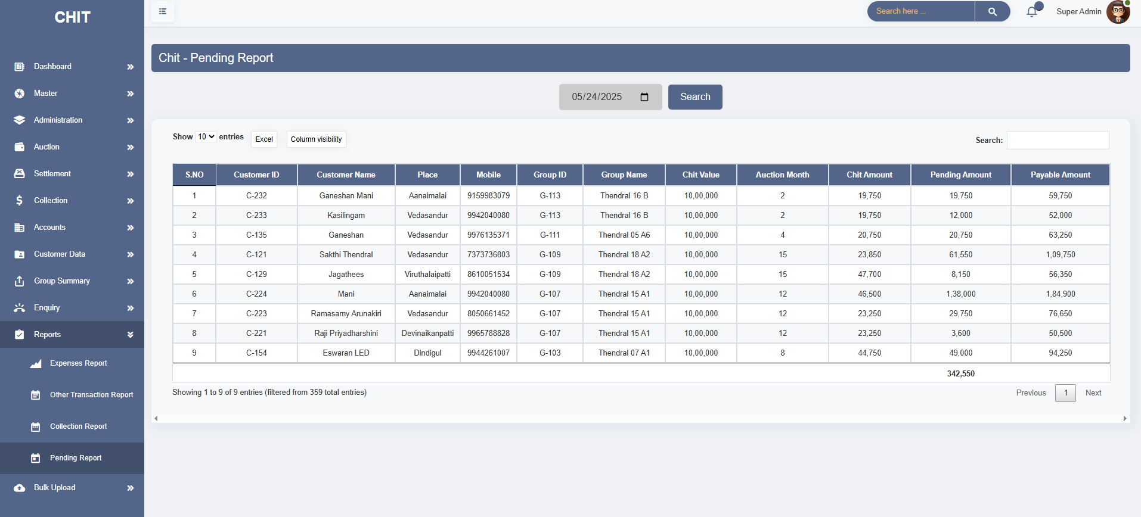

**12. BULK UPLOAD**

* The **Bulk Upload** feature in the Chit application is designed to streamline the process of mass data entry for key chit operations. It allows administrators to import multiple records at once using an Excel file, reducing manual entry time and minimizing errors.
* In the **Group Creation** section, administrators can upload an Excel file containing details such as Group ID, Group Name, Start Month, End Month, Total Members, and Grace Period. This feature allows the creation of multiple chit groups in a single operation, ensuring that the system is automatically populated with all essential group data. Once uploaded, the groups are initialized and become ready for customer mapping and auction scheduling.
* The **Customer Creation** option allows bulk entry of customer information. The uploaded Excel should include fields like Customer ID, Name, Mobile Number, Place, and Occupation, along with the Group ID they are mapped to and their Chit Share Percentage.
* The **Auction and Settlement** category is designed to upload auction-related and settlement-specific data. The Excel file must include details such as Group ID, Auction Month, Auction Date and Time, High and Low Auction Values, Winning Customer Name, Bid Amount, and Settlement Information (like Disbursed Amount, Payment Mode, and Guarantor details

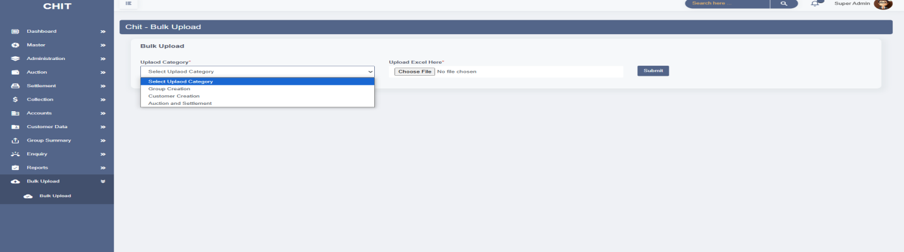

**BULK UPLOAD EXCEL FORMAT**

**Group Creation**

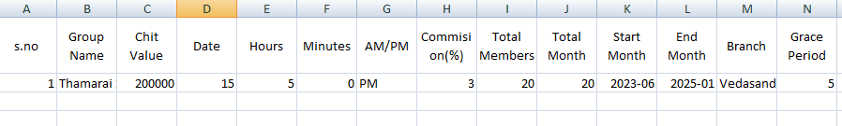

**Customer Creation**

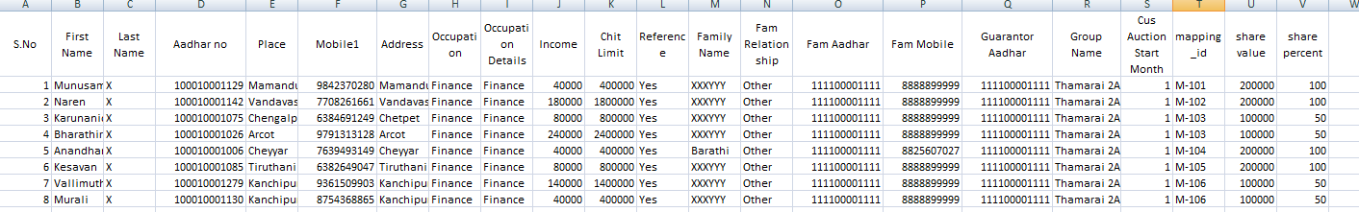

**Auction and Settlement**

